|  |  |
| --- | --- |
| **Appendix A: ASSIGNMENT COVER SHEET**  **Description: Z:\Rakhee\Work\Logo\LOGO'S\REGENT Business School.jpg** | |
| ***Programme*** | **MASTER OF BUSINESS ADMINISTRATION (NQF 9)** |
| ***Module Name*** | Project Management |
| ***Surname*** | Mtombeni |
| ***First Name/S*** | Phillip Mandla |
| ***Student Number*** | 516000131 |
| ***Date Submitted*** | 14 April 2020 |
| ***Postal Address*** | 4 Midrand Ridge |
| George Road |
| NoordWyk Ext1 |
| Midrand 1687 |
| ***E-MAIL***  ***myregent email address*** | **516000131@myregent.ac.za** |
| ***E-Mail***  ***(alternate email address)*** | pmmtombeni@gmail.com |
| ***Contact Numbers*** | **Cell :0765685999** |
| **Home :**076 544 4098 |
| **Work :0116326930** |
| ***Alternate contact :***  ***Name:***  ***Relationship:***  ***Contact number:*** |  |
| Tsholofelo |
| Wife |
| 0827230343 |

I PHILLIP MANDLA_MTOMBENI ID/Passport No. 8012145460082 hereby confirm that the assignment submitted herein is my own original work.

Date: 14 April2020

Table of content

Question 1.1……………..…………………….…………..…………….………………..4

Question 1.2………………………………….………………………….………………..6

Question 1.3………………………………………..…..…………………………………7

Question 1.4………………………………………..…..…………………………………9

Question 1.5.1…………………………….………..…..…………………………………11

Question 1.5.2………………………….…………..…..…………………………………14

Question 2.1………………………………………..…..…………………………………17

Question 2.2……………………………….………..…..…………………………………19

Question 3…………………….……….…………..…..…………………………………..20

References…….……………………….…………..………………………………………22

Question 1.1

This section discusses SWOT analysis of challenger bank and a traditional bank which is TymeBank and FirstRand (FNB)

|  |  |
| --- | --- |
| STRENGTH  In the past few months, three new banks have launched with a leaner, cheaper business model that will change the face of SA banking — Discovery Bank, TymeBank and Bank Zero.  But these three new banks are backed by formidable business personalities with deep pockets.  Tyme Bank is controlled by African Rainbow Capital (ARC), an investment company controlled by the eclectic Ubuntu-Botho group headed by Patrice Motsepe. As the Forbes rich list has it, Motsepe is one of the 1,000 wealthiest individuals in the world, with a fortune of $2.4bn. Before it was bought by Motsepe’s company, TymeBank was owned by the Commonwealth Bank of Australia (CBA), one of the world’s top 10 retail banks.  As for Bank Zero, the most entrepreneurially based of the three, it shows how far the Reserve Bank has come that it got the green light. Bank Zero is run by a maverick group of former FNB executives, most of them with strong technology backgrounds, with a few family and friends as shareholders. The chair and figurehead is the former FNB boss Michael Jordaan, based in Stellenbosch.  Somewhat ironically, Jordaan is Motsepe’s partner in the data-only telecom network Rain.  The Bank Zero CEO, Yatin Narsai (former head of FNB retail), runs the business day-to-day from Bryanston.  Low fees will become the new normal and I hope that penalty fees will disappear altogether,which is introduced by TymeBank  And yet the big four still have 83% of all bank deposits in the country and 92% of all mortgages, which shows how concentrated the market still is.  **Discovery, TymeBank and Bank Zero** are pursuing a branchless model, with their apps being their shop window.  Botha says Standard’s natural market share has fallen thanks to the success of Capitec and FNB, in different parts of its client base.  TymeBank chair Coen Jonker tells the *FM*: "The banks have done their best to protect their legacy income streams for years.  The big four banks have long operated as if they were an informal cartel.  As many of Capitec’s transactional clients earn interest of 5% on their deposits, they often get more money coming in than they pay in fees. These new banks would appear, in part, to be targeting that market.  Tyme will have 750 points of sale through Pick n Pay and Boxer stores. This gives it reach into the main urban areas, as well as the rural areas where few banking services are typically available.  Most transactions are free if carried out at Pick n Pay or Boxer, and cost only R2 if done elsewhere, and the bank pays up to 10% interest on positive balances. TymeBank has such low costs because it is cloud-based and highly scalable, and has minimised the bells and whistles.  Incredibly, there are just 125 staff keeping the bank running. Clients can join through the TymeBank website, but by far the most popular recruitment tool has been self-service kiosks, which provide a new card within five minutes.  TymeBank, he says, will ride the wave away from cash transactions to digital payments. "We expect the amount of cash in the system to be cut back by two-thirds over the next three years. Increasingly shareholders in the Ubuntu-Botho group find carrying cash dangerous. We were able to issue 1-million cards to members of the Zion Christian Church to facilitate cashless transactions," he says.  For now though, Pick n Pay stores are more than happy to offer excess cash to TymeBank customers at no charge. The retailer’s deputy CEO, Richard van Rensburg, says Capitec also recommends its customers draw money at Pick n Pay tills because it is far cheaper than using an ATM.  And a central feature of TymeBank is its access to the information gathered by Pick n Pay on the 11-million members of its Smart Shopper programme, which provides rewards points on all purchases, not just at Pick n Pay. And unlike Discovery, that benefit is not confined to healthy foods. In a much less judgmental way, all purchases qualify.  Whereas TymeBank has developed products exclusively for digital clients. He says he would not try to set up a bank as a subsidiary of a retailer again, but an alliance between a retailer and a bank makes sense.  Narsai, as head of FNB retail, is even more deeply entrenched in IT than Jordaan. "I am impressed that TymeBank has signed up 120,000 customers in a few months," he says. "[It shows] there is pent-up demand for a good-value, no-frills bank account.  Narsai says most banks opt for off-the-shelf IT systems  **For Jordaan, it’s a natural evolution**. Now living in Stellenbosch, he became CEO of FNB when he was just 36, creating an institution that grabbed plaudits as "the world’s most innovative bank" in 2012. The risk and capital requirements are significant.  He says he thrived in the entrepreneurial FirstRand culture fostered by the three founders — GT Ferreira, Laurie Dippenaar and Paul Harris — who embraced start-up ventures such as Discovery and Outsurance.  This inspired him to become a backer of small business.  Jordaan left FNB in 2013, because he says 10 years of commuting from Stellenbosch to Johannesburg was enough. There was no love lost between him and Discovery (another FirstRand subsidiary at the time), which he called the enfant terrible of the group and a disrupter, in the days when that was still a swear word.  But one of the mutual banks benefits of the structure is that it allows customers to become shareholders.  To date FNB has been the leading bank for innovative features, such as registering as a customer using a selfie from your phone.  Gore says Discovery could not opt for a simpler cloud-based solution, as Tyme Bank has done.  This suggests it will take longer for Gore’s bank to make a profit than either of its more nimble competitors, Bank Zero and TymeBank, and the marketing spend will be higher.  At least, in most cases, the big four banks still own the relationship with the customer and can persuade them to stay.  Botha says they can be expected to increase their credit spreads on loans to make up for the lost fee income. Capitec is likely to be the least affected, says Chetty, given that it already has a competitive current account with low fees.  Three new banks are set to change the face of SA banking with a leaner, cheaper business model.  But the fact that TymeBank already has 120,000 clients is evidence that perhaps the time is now right.  While there’s electricity in the air in the banking sector for the first time in years, it won’t be a one-way bet.    While Bank Zero is entirely app based, Tyme at least enjoys some advertising through its black and yellow machines at Pick n Pay stores, and has started flighting prime-time TV adverts to lure clients.  Still, it’s clear that Discovery Bank won’t be matching the costs of TymeBank and Bank Zero item-for-item, at least for the average client.  Gore says banks operate on three legs: fees, interest and rewards. Some banks (like Capitec and the other newcomers) will offer competitive fees and attractive interest on accounts but no rewards programme; while the large banks pay little or no interest on current accounts but have decent rewards programmes.  The three new banks are not just aiming for the tech-savvy. TymeBank’s former parent, CBA, has a larger market cap than the entire SA banking sector, though it took a softly-softly approach to the new bank. Even before Tyme was registered, it offered money transfer services from Pick n Pay.  It is almost an accident that Motsepe’s ARC took full control of the bank after CBA pulled out suddenly to retreat to its home market and cut exposure to emerging markets, opportunity for TymeBank.  Johan van Zyl, the co-CEO of ARC (and chair of Sanlam) says he was pleased CBA was the controlling shareholder while the bank was being registered because it is a bureaucratic, by-the-book organisation with huge experience of banking regulation.  **For Jordaan, it’s a natural evolution**. Now living in Stellenbosch, he became CEO of FNB when he was just 36, creating an institution that grabbed plaudits as "the world’s most innovative bank" in 2012.  The big four banks have long operated as if they were  an informal cartel FNB is one of them. | WEAKNESS  For two decades, SA’s banking sector has remained  largely the same  Banking changed even more slowly. More than 25 years after the  launch of the internet, most banks still distribute a large portion of their products through a branch network. These branches will still be perfectly  recognisable to anyone visiting SA for the first time in 30 years,  FNB owns some of these  branches.  Discussing the rationale for the bank in an interview with the *FM*,  Narsai says SA ranks among the five countries with the highest  bank fees in the world. "This is intolerable in such an unequal  society, but then the rest of the bottom five were similarly  unequal countries in Latin America," he says.  Harry Botha, a banks analyst at Avior Capital, says it could take  three to five years for the challenger banks to make material  inroads into the large banks’ earnings.  However, Chetty says clients who have a loan with Capitec are  unlikely to move their transactional accounts to the new banks  in a hurry.  "Banking will never be free," says Capitec CEO Gerrie Fourie in  an interview with the *FM*.  Though Tyme doesn’t have any of its own branches.  Boxer customers are more likely to be unbanked, so could prove  the most fertile hunting ground for Tyme.  Capitec’s Fourie warns, however, that while new fintech  technology providers might be adding value, they fall short on  wo issues — handling volume and maintaining security a  weakness for Tymebank  Mutual banks might have a bad name after the collapse of  VBS last year under a mountain of fraud.  This network of brokers and agents is something that  TymeBank and Bank Zero don’t have.  At the moment, Capitec has 840 branches, though many are  smaller than those of the big banks. The branches have proven  invaluable as the predominant sales point for the  half-a-million Sanlam funeral policies sold through Capitec over  the past year, FNB must also reduce branches  Already they’re scrambling, introducing innovations like joining  up with just a selfie. But they may have left it too late to ride  the tsunami of change.  Avior’s Botha says SA is still a long way from a zero-fee  banking regime, even among the new entrants. But fixed monthly  fees and charges for electronic transactions could come to an end  sooner rather than later.  Bank Zero and TymeBank, and the marketing spend will be higher.  Harry Botha, a banks analyst at Avior Capital, says it could take  three to five years for the challenger banks to make material  inroads into the large banks’ earnings.  This means there are now 8 million more credit-active consumers  than employed people — a big riskto society. |
| **OPPORTUNITIES**  CEO Sandile Shabalala says the bank will start offering loans next year. It plans to offer keener lending rates because, like Capitec, it will be able to cross-subsidise its transaction and deposit books from its loan income. The tipping point for Tyme, at which it becomes profitable, is 2-million customers and 700,000 loans.  Though price alone might not be enough to propel the new banks into profit, they are launching at a time of considerable unhappiness over bank fees. It is easier than ever, through apps, to compare fees.  Customers were desperate for something different; this is an opportunity that Tymebank can use.  Standard Bank CEO Sim Tshabalala called it "realigning the retail and business banking model to the changing needs of customers". And, of course, the convenience of digital banking makes so much more sense than travelling to a branch and queuing.  "We would like to bring in an equity partner as we prefer to hold minority positions in companies, not the 73% we currently hold, but it is not an imperative," he says. | **THREATS**  No-one can ignore the competitive threat of cheap banking this is  a threat to FNB.  Now, three new banks — all backed by powerful SA  business personalities — are opening their digital doors,  offering something entirely different. So what can they offer  that’s new, and how much of a threat is this for the ‘big four’  banks?  None of the big banks will rock the boat; they want to protect  their collective income. That era has come to an end  The question, however, is what the existing big four banks — FNB  , Standard Bank, Absa and Nedbank — will do to counter the  threat. "The big banks ignored Capitec in the early 2000s," says  Louis Chetty, head of financials at Stanlib, "and lost considerable  market share. I am sure they will not make the same mistake again.  The transactional fees on simply taking money in and out of  accounts is the hardest to justify” FNB is one of the banks. As  new banks we won’t have that legacy to defend."  But fixed monthly fees and charges for electronic transactions could come to an end sooner rather than later.  This means it will be the big four who will bear the brunt of the industry disruption.  Says Botha: "The big banks will cut fees, but only gradually —  they need to cut costs first before they can afford to do so  Until now, none of the large banks has been prepared to  jeopardise their lucrative income stream from transactional  fees with a price war. But now they will have no choice, threat  to FNB.  Van Zyl says the Reserve Bank does not want TymeBank to  become a Sanlam group company as it wants to keep banks  and insurers as separate as possible.  . |

Yes, I agree, the case study shows that the big four banks have long operated as if they were an informal association, this is true the article mentioned that : South Africa’s banking sector is dominated by its big four banks. Together they share almost 95% of the assets in this mature market, in which up to 80% of customers are already banked. For two decades, SA’s banking sector has remained largely the same. The advent of Capitec, in 2001, showed that customers were desperate for something different. Now, three new banks — all backed by powerful SA business personalities — are opening their digital doors, offering something entirely different. So what can they offer that’s new, and how much of a threat is this for the ‘big four’ banks?

Financial services used to change slowly. Twenty years after Douw Steyn launched the direct-to-consumer insurer Auto & General in 1985, insurance was still largely sold through brokers, and index funds still accounted for a tiny portion of investment assets. As a result, investment in digital service innovation and customer solutions has so far been slow and focused on targeted back-office processes, only recently ramping up more widely in response to low customer satisfaction with banks’ services and accessibility. Banking changed even more slowly. More than 25 years after the launch of the internet, most banks still distribute a large portion of their products through a branch network. These branches will still be perfectly recognisable to anyone visiting SA for the first time in 30 years. None of the big banks will rock the boat; they want to protect their collective income. That era has come to an end. In the past few months, three new banks have launched with a leaner, cheaper business model that will change the face of SA banking — Discovery Bank, TymeBank and Bank Zero. Incumbent banks have focused on customer-value propositions and pricing as their main growth drivers in recent years. However, new entrants such as Discovery Bank, Tyme Bank and Bank Zero are set up to challenge the status quo with innovative servicing and lower-priced banking.

The idea of going “greenfield”, at a bank, segment or even product level, is an easy one to dismiss. In the past, banks took years to set up and decades to build up a customer base: but not any more as recent history shows, especially if you are already a bank.

It’s been a long time coming. After Saambou and Fidelity Bank collapsed in the early 2000s, the SA Reserve Bank was for a long time reluctant to let new banks open. Discussing the rationale for the bank in an interview with the *FM*, Narsai says SA ranks among the five countries with the highest bank fees in the world. "This is intolerable in such an unequal society, but then the rest of the bottom five were similarly unequal countries in Latin America," he says. No-one can ignore the competitive threat of cheap banking. Narsai says he personally will save R2 000 a month from his personal and business accounts, when Bank Zero goes live and he can move accounts. "

Low fees will become the new normal and I hope that penalty fees will disappear altogether," he says.

Capitec has more than 10-million customers, who will have been enticed, in part, by the much lower cost of banking. And yet the big four still have 83% of all bank deposits in the country and 92% of all mortgages, which shows how concentrated the market still is. Harry Botha, a banks analyst at Avior Capital, says it could take three to five years for the challenger banks to make material inroads into the large banks’ earnings. Harry Botha, a banks analyst at Avior Capital, says it could take three to five years for the challenger banks to make material inroads into the large banks’ earnings. But, globally, this is the trend. No-one should have been surprised by Standard Bank’s announcement two weeks ago that it was closing up to 15% of its branch network — or 91 branches. Botha says Standard’s natural market share has fallen thanks to the success of Capitec and FNB, in different parts of its client base.

Standard Bank CEO Sim Tshabalala called it "realigning the retail and business banking model to the changing needs of customers". And, of course, the convenience of digital banking makes so much more sense than travelling to a branch and queuing. TymeBank chair Coen Jonker tells the *FM*: "The banks have done their best to protect their legacy income streams for years, and the transactional fees on simply taking money in and out of accounts is the hardest to justify. As new banks we won’t have that legacy to defend." The big four banks have long operated as if they were an informal cartel. Even the one entrant in the past 20 years to grow to large-bank status, Capitec, has adopted a traditional branch-based distribution model. At the moment, Capitec has 840 branches, though many are smaller than those of the big banks. The branches have proven invaluable as the predominant sales point for the half-a-million Sanlam funeral policies sold through Capitec over the past year. Avior’s Botha says SA is still a long way from a zero-fee banking regime, even among the new entrants. But fixed monthly fees and charges for electronic transactions could come to an end sooner rather than later. Discovery Bank will charge both sets of fees — at least for now. Gore says banks operate on three legs: fees, interest and rewards. Some banks (like Capitec and the other newcomers) will offer competitive fees and attractive interest on accounts but no rewards programme; while the large banks pay little or no interest on current accounts but have decent rewards programmes.

Gore says Discovery will not attempt to beat the market on fees, for a combined current account and credit card. You might have expected Pick n Pay to have cold feet after the failure of its Go Banking venture with Nedbank in the mid-2000s. But Van Rensburg argues that Go Banking offered similar services to Nedbank, whereas TymeBank has developed products exclusively for digital clients. He says he would not try to set up a bank as a subsidiary of a retailer again, but an alliance between a retailer and a bank makes sense. Pick n Pay CEO Richard Brasher is also the founder of Tesco Bank, which is owned by the UK’s largest supermarket chain. Narsai says most banks opt for off-the-shelf IT systems, where both the risk and capital requirements are significant. Bank IT managers naturally gravitate towards packages conforming to past norms, which tend to create a "me too" starting point.

To date FNB has been the leading bank for innovative features, such as registering as a customer using a selfie from your phone. Hore insists you don’t have to be a gym bunny to get a good deal from the bank — people with no other Discovery product still get a 25% discount on fuel and healthy food. But these are the frills. Discovery has not yet revealed how it plans to recoup the considerable start-up costs. It has spent close to R4.5bn between developing the bank systems (which, like those of Standard Bank, are based on SAP products) and buying back the Discovery credit card from FNB. Gore challenges the view, expressed by FirstRand CEO Alan Pullinger recently, that SA’s banks already use a behavioural approach to assess the quality of their clients when it comes to risk. "We don’t agree," says Gore. Most banks reward clients for taking out more products, which specifically increases their debt and credit levels, he says. This means there are now 8-million more credit-active consumers than employed people — a big risk to society. "We don’t push products, but encourage [customers] to follow key behaviour to secure financial health. Hore says it will set personalised goals based on an individual’s circumstances, and will have a wider product range on day one than its rivals.

Three new banks are set to change the face of SA banking with a leaner, cheaper business model .Back then, there were fewer smartphones (it was the age of BlackBerry) and the environment wasn’t inherently as friendly for digital products as it is today. 20Twenty, for example, operated largely through a call centre, and the customer experience was often indifferent. Until now, none of the large banks has been prepared to jeopardise their lucrative income stream from transactional fees with a price war. But now they will have no choice. Says Botha: "The big banks will cut fees, but only gradually — they need to cut costs first before they can afford to do so. "At least, in most cases, the big four banks still own the relationship with the customer and can persuade them to stay. Botha says they can be expected to increase their credit spreads on loans to make up for the lost fee income. Capitec is likely to be the least affected, says Chetty, given that it already has a competitive current account with low fees. Says Botha: "The big banks will cut fees, but only gradually — they need to cut costs first before they can afford to do so. " At least, in most cases, the big four banks still own the relationship with the customer and can persuade them to stay. Botha says they can be expected to increase their credit spreads on loans to make up for the lost fee income. Capitec is likely to be the least affected, says Chetty, given that it already has a competitive current account with low fees.

This means it will be the big four who will bear the brunt of the industry disruption. Already they’re scrambling, introducing innovations like joining up with just a selfie. But they may have left it too late to ride the tsunami of change. Traditional banks that will survive are those that will successfully integrate the new technologies with innovative servicing and lower fees.

Only Investec has operated without branches and all the big four banks are having branches across the country — but to a narrow spectrum of high net worth clients. Interestingly, Capitec is the only bank that is actually increasing its branch footprint, even though 2.2-million clients have migrated to the app and 4-million to the USSD (SMS-based) transactional platform. At the moment, Capitec has 840 branches, though many are smaller than those of the big banks.

This means it will be the big four who will bear the brunt of the industry disruption. Already they’re scrambling, introducing innovations like joining up with just a selfie. But they may have left it too late to ride the tsunami of change. The question, however, is what the existing big four banks — FNB, Standard Bank, Absa and Nedbank — will do to counter the threat. "The big banks ignored Capitec in the early 2000s," says Louis Chetty, head of financials at Stanlib, "and lost considerable market share. I am sure they will not make the same mistake again." Traditional banks that will survive are those that will successfully integrate the new technologies with innovative servicing and lower fees.

Question 1.3

1.3 Evaluate the business model of the challenger banks mentioned in the article.

A business model defines the rationale of how a company captures, delivers, and creates

value, in cultural, social, economic , or other contexts. In addition the business model modification and construction process is named business model **innovation** and it is forming a business strategy part.

In practice and theory , the business model term is utilized for a wide range of formal and informal descriptions to indicate the core business aspects, involving trading practices,

sourcing, organizational structures, infrastructure, strategies, offerings,

target customers, business process, purpose, and operational policies and processes involving culture.

Business models is the design of company’s structures to validate a commercial opportunity. Additional extensions to such design logic highlights the utilization of coherence or narrative in descriptions of business model as mechanisms where entrepreneurs develop extremely successful growth firms.

Business models are utilized to classify and describe businesses, mostly in an entrepreneurial setting, yet in addition they are utilized by managers within organizations in exploring future development possibilities. Business models which is well-known may operate as "recipes" for managers who are creative. Additionally business models are referred to in other instances in the accounting context for public reporting purposes.

Business model includes providing a basic product at a cheap price very low cost, frequently at a loss, therefore one must charge compensatory recurring money for associated services or products, or for refills . Examples involve : digital banking; cell phones  and air time ; cameras  and prints; computer printers  and ink cartridge refills ; and razor  and blades.

In simple terms, a robust process should make common business sense. The benefits of using the process should exceed the cost and efforts expended to design, execute, and maintain the process. The business side of a robust process sometimes involves leasing agreements, maintenance agreements, and service level agreements. **Business Models** – Various structures, processes, and other mechanisms that businesses and other organizations use for organizing the way they interact with their primary external stakeholders (e.g., customers and suppliers) to achieve their primary goal (e.g., maximization of profit). The advent of Capitec, in 2001, showed that customers were desperate for something different. Now, three new banks — all backed by powerful SA business personalities — are opening their digital doors, offering something entirely different. So, what can they offer that’s new, and how much of a threat is this for the ‘big four’ banks?

*prosper even in tough economic*

*conditions.*

Challenger banks business model includes a learning culture , they focus on increasing knowledge, competence and performance. They were able to introduce innovation as part of their strategy hence they came up the idea of digital banking. The business model includes customer-centric culture they focus on products ,services and employees efforts on creating happy, loyal customers.

The challenging banks which are Discovery Bank, TymeBank and Bank Zero were innovative by introducing digital disruption and this results to low banking fees and some are using clouds. Our recent experience and that of new digital players shows that though launching a digital greenfield would have been difficult just a few years ago, it is now feasible in under 12 months and at a reasonable cost.

Bank Zero as one of the challenger banks is intending to create a niche offering. Its mutual bank business model is aiming to appeal to digital communities, by tapping into groups of like-minded clients that want to take part in the broad benefits of mutual ownership. As an outcome, investment in customer solutions and digital service innovation has focused on targeted back-office processes, only recently ramping up more widely in response to low customer satisfaction with banks’ services and accessibility.

South Africa is noticing its 1st wave of digital challengers coming into the market, with 3 new banks launching in 2019, these challenger banks bring a differentiated value proposition to customers.

The challenging banks are charging a small margin for the services, these successful digital banks are able to create a profitable business model.

The first step for the universal banks to compete on an equal footing with fast-paced digital entrants is to develop a clear, enterprise-wide innovation strategy and operating model. We have seen large organisations promoting innovation through a variety of different models, from agile change teams developing core product and process in each business unit, to arms-length incubators and venture funds

The case study discusses digital banking business model,a cheaper business model , branchless model ,and cloud banking lets look at these in detail:

Three new banks are set to change the face of SA banking with a leaner, cheaper business model.

Banking changed even more slowly. More than 25 years after the launch of the internet, most banks still distribute a large portion of their products through a branch network. These branches will still be perfectly recognisable to anyone visiting SA for the first time in 30 years. None of the big banks will rock the boat; they want to protect their collective income. That era has come to an end. In the past few months, three new banks have launched with a leaner, cheaper business model that will change the face of SA banking — Discovery Bank, TymeBank and Bank Zero.

**Discovery, TymeBank and Bank Zero** are pursuing a branchless model, with their apps being their shop window. This means SA isn’t far behind the rest of the world: the first app-only current account in the UK was introduced by Starling Bank just two years ago. Perhaps if the Reserve Bank had been more open-minded, SA could have beaten them to the punch.

The case study states that now, three new banks — all backed by powerful SA business personalities — are opening their digital doors, offering something entirely different. So what can they offer that’s new, and how much of a threat is this for the ‘big four’ banks?

Standard Bank CEO Sim Tshabalala called it "realigning the retail and business banking model to the changing needs of customers". And, of course, the convenience of digital banking which is introduced by challenger banks makes so much more sense than travelling to a branch and queuing.

TymeBank as one of the challenger banks , will ride the wave away from cash transactions to digital payments. "We expect the amount of cash in the system to be cut back by two-thirds over the next three years. Increasingly shareholders in the Ubuntu-Botho group find carrying cash dangerous. We were able to issue 1-million cards to members of the Zion Christian Church to facilitate cashless transactions," he says.

You might have expected Pick n Pay to have cold feet after the failure of its Go Banking venture with Nedbank in the mid-2000s. But Van Rensburg argues that Go Banking offered similar services to Nedbank, whereas TymeBank has developed products exclusively for digital clients. He says he would not try to set up a bank as a subsidiary of a retailer again, but an alliance between a retailer and a bank makes sense.

Fees were a big part of this success. Capitec has a nominal monthly fee of R5, with R1 charged for each digital transaction. Cash withdrawals are more expensive at R6 for the first R1 000 at a Capitec ATM, or a flat R1.60 at till points of retailers like Pick n Pay or Shoprite. As many of Capitec’s transactional clients earn interest of 5% on their deposits, they often get more money coming in than they pay in fees.

These new banks would appear, in part, to be targeting that market

Ccccccccccccc

The three new banks are not just aiming for the tech-savvy. TymeBank’s former parent, CBA, has a larger market cap than the entire SA banking sector, though it took a softly-softly approach to the new bank. Even before Tyme was registered, it offered money transfer services from Pick n Pay.

Though Tyme doesn’t have any of its own branches, it will have 750 points of sale through Pick n Pay and Boxer stores. This gives it reach into the main urban areas, as well as the rural areas where few banking services are typically available. Boxer customers are more likely to be unbanked, so could prove the most fertile hunting ground for Tyme.

Most transactions are free if carried out at Pick n Pay or Boxer, and cost only R2 if done elsewhere, and the bank pays up to 10% interest on positive balances. TymeBank has such low costs because it is cloud-based and highly scalable, and has minimised the bells and whistles. Incredibly, there are just 125 staff keeping the bank running. Clients can join through the TymeBank website, but by far the most popular recruitment tool has been self-service kiosks, which provide a new card within five minutes.

CEO Sandile Shabalala says the bank will start offering loans next year. It plans to offer keener lending rates because, like Capitec, it will be able to cross-subsidise its transaction and deposit books from its loan income. The tipping point for Tyme, at which it becomes profitable, is 2-million customers and 700,000 loans.

FEES

As for Bank Zero, the most entrepreneurially based of the three, it shows how far the Reserve Bank has come that it got the green light. Bank Zero is run by a maverick group of former FNB executives, most of them with strong technology backgrounds, with a few family and friends as shareholders. The chair and figurehead is the former FNB boss Michael Jordaan, based in Stellenbosch.

Discussing the rationale for the bank in an interview with the *FM*, Narsai says SA ranks among the five countries with the highest bank fees in the world. "This is intolerable in such an unequal society, but then the rest of the bottom five were similarly unequal countries in Latin America," he says.

No-one can ignore the competitive threat of cheap banking. Narsai says he personally will save R2 000 a month from his personal and business accounts, when Bank Zero goes live and he can move accounts. "Low fees will become the new normal and I hope that penalty fees will disappear altogether," he says.

Jordaan may just be the nonexecutive chair of Bank Zero, but with his deep knowledge of new technologies, the market seems confident that his bank will be impressive from the start.

Narsai, as head of FNB retail, is even more deeply entrenched in IT than Jordaan. "I am impressed that TymeBank has signed up 120,000 customers in a few months," he says. "[It shows] there is pent-up demand for a good-value, no-frills bank account. But we will be offering considerably more sophisticated functionality."

Other FNB renegades at Bank Zero are chief risk officer Lezanne Human (who also moonlights as the informal head of public affairs), and co-founder and CFO Liné Wiid. Bank Zero, as a mutual bank, will focus on deposits and transactional banking and will not offer loans for the foreseeable future.

oooooooooooooooo

TymeBank chair Coen Jonker tells the *FM*: "The banks have done their best to protect their legacy income streams for years, and the transactional fees on simply taking money in and out of accounts is the hardest to justify. As new banks we won’t have that legacy to defend."

The big four banks have long operated as if they were an informal cartel. Even the one entrant in the past 20 years to grow to large-bank status, Capitec, has adopted a traditional branch-based distribution model.

Only Investec has operated without branches — but to a narrow spectrum of high net worth clients. To see what sort of riches are up for grabs, consider Capitec’s trajectory. In its first year on the JSE in 2002, Capitec made revenue of R270m, with just a smattering of clients. By August 2018, it was clocking up R9.3bn in operating income with its 10.5-million customers. Its share price has reacted accordingly: R10 000 invested in the bank at the beginning would now be worth R7.2m

Fees were a big part of this success. Capitec has a nominal monthly fee of R5, with R1 charged for each digital transaction. Cash withdrawals are more expensive at R6 for the first R1 000 at a Capitec ATM, or a flat R1.60 at till points of retailers like Pick n Pay or Shoprite. As many of Capitec’s transactional clients earn interest of 5% on their deposits, they often get more money coming in than they pay in fees.

Discovery Bank’s lower-income clients (those earning less than R300,000 a year) will pay Avior’s Botha says SA is still a long way from a zero-fee banking regime, even among the new entrants. But fixed monthly fees and charges for electronic transactions could come to an end sooner rather than later.

Discovery Bank will charge both sets of fees — at least for now.

Gore says banks operate on three legs: fees, interest and rewards. Some banks (like Capitec and the other newcomers) will offer competitive fees and attractive interest on accounts but no rewards programme; while the large banks pay little or no interest on current accounts but have decent rewards programmes.

Gore says Discovery will not attempt to beat the market on fees, for a combined current account and credit card.

Discovery Bank’s lower-income clients (those earning less than R300,000 a year) will pay between R149 and R186 a month in fees; middle-income customers will pay between R213 and R240; and higher-income clients will pay between R275 and R440. For a pure transactional account the fee will be R60 to R120, but as Discovery has no ATMs, cash withdrawal fees will be higher.

But if it won’t compete on fees, Discovery Bank will be second to none with its Vitality Money rewards programme, and the sophisticated way in which it encourages the right financial behaviour.

Discovery Bank will match Capitec’s 5% interest rate on positive current account, and add an extra 1.5% for those in the top tier of the Vitality programme.

The three new banks are not just aiming for the tech-savvy. TymeBank’s former parent, CBA, has a larger market cap than the entire SA banking sector, though it took a softly-softly approach to the new bank. Even before Tyme was registered, it offered money transfer services from Pick n Pay.

Narsai promises a "creative" solution for clients who might go modestly into the red. But he also hopes to nurture a savings culture through attractive interest rates. Initially, the team had planned to focus on high-margin areas, particularly remittances from neighbouring countries, but they soon realised they had the capability to launch a full-service bank.

Jordaan tells the *FM* that Bank Zero, launching in the second half of 2019, will make money through the interest it charges, fees on third-party transactions and commissions on prepaid products such as airtime. "But with our low break-even you can expect lots of zeros where other banks charge fees," says Jordaan.

Mark Elliott, president of Mastercard Southern Africa, says he is working with Bank Zero to develop a new kind of card that can deliver better security, which is appropriate for today’s increasingly mobile and digital customers.

Bank Zero also keeps costs down by using the cloud, but the heart of the business will be its IBM LinuxOne enterprise server, which uses (free) open-source software. Perhaps Bank Zero’s most serious competitor, at least in the small to medium business sector, could be Mercantile, once it is revitalised under Capitec’s ownership.

Narsai says most banks opt for off-the-shelf IT systems, where both the risk and capital requirements are significant. Bank IT managers naturally gravitate towards packages conforming to past norms, which tend to create a "me too" starting point.

"We have preferred to build our platform to clearly defined bank specifications. We are very comfortable doing this with our deep expertise. And we can design from the ground up for today’s issues such as regulation and cybercrime," he says.

Capitec’s Fourie warns, however, that while new fintech technology providers might be adding value, they fall short on two issues — handling volume and maintaining security. It’ll be interesting to see how Bank Zero navigates this.

Jordaan says all the Bank Zero shareholders are active as executives or active directors, with skin in the game.

"Without a big corporate shareholder, we can take a much longer-term view," he says. "We have a cohesive strategy to bring significant customer benefits without the pressure to produce short-term profits."

Jordaan says all the Bank Zero shareholders are active as executives or active directors, with skin in the game.

"Without a big corporate shareholder, we can take a much longer-term view," he says. "We have a cohesive strategy to bring significant customer benefits without the pressure to produce short-term profits."

Mutual banks might have a bad name after the collapse of VBS last year under a mountain of fraud, but one of the benefits of the structure is that it allows customers to become shareholders.

If Bank Zero’s model is simple, Discovery Bank’s is the opposite.

The launch included a 70-page "thought leadership" document with chapters on such warm and fuzzy notions as "shared value", "behaviour change" and "people-centric" design. Still, Discovery Bank’s CEO, Barry Hore, promises that the app will be simple to use, once clients get used to it. "It is multifunctional, a bank branch in the palm of the hand," he says.

Interesting features of its model include Discovery Pay, which allows clients to pay any other client without needing to register the person as a beneficiary. Pharmacy co-payments can also be automatically deducted from the bank account.

To date FNB has been the leading bank for innovative features, such as registering as a customer using a selfie from your phone. But Hore says the Discovery platform will ensure that bank customers never need to visit a branch, even to open an account, and from day one cardless capabilities such as Samsung Pay, Garmin Pay and FitBit Pay will be available.

lzzzzzzzzzzzzzzzzzzzzzzzzzzzzzzz

Gore says Discovery could not opt for a simpler cloud-based solution, as Tyme Bank has done, because its system needs to accommodate the complex links between the bank and its Vitality programme and the company’s health, life, investment and insurance businesses.

Though price alone might not be enough to propel the new banks into profit, they are launching at a time of considerable unhappiness over bank fees. It is easier than ever, through apps, to compare fees. Until now, none of the large banks has been prepared to jeopardise their lucrative income stream from transactional fees with a price war. But now they will have no choice.

Says Botha: "The big banks will cut fees, but only gradually — they need to cut costs first before they can afford to do so. "At least, in most cases, the big four banks still own the relationship with the customer and can persuade them to stay. Botha says they can be expected to increase their credit spreads on loans to make up for the lost fee income. Capitec is likely to be the least affected, says Chetty, given that it already has a competitive current account with low fees.

//////

It’s been a long time coming. After Saambou and Fidelity Bank collapsed in the early 2000s, the SA Reserve Bank was for a long time reluctant to let new banks open. But these three new banks are backed by formidable business personalities with deep pockets.

Discovery Bank is part of the wider group run by CEO Adrian Gore, which began as a health-care company in 1993. Discovery boasts Remgro associate Rand Merchant Investments (RMI) as its anchor shareholder.

?????????????

The Discovery Bank app went live this week, and the first stage is to migrate former clients of Discovery Card (which was backed by the FNB platform) into the bank. It will necessarily be a slow process to avoid anything going wrong. But by June, the first 10,000 clients are expected to be onboard.

Discovery’s advantage is that unlike the other two new banks, it is already a household brand. It also has a good chance of capturing the majority of its credit card clients (bought back from FNB) and a sizeable slice of its medical aid and insurance clients. Already, the group’s Vitality programme has cult status among some, and if you believe

their marketing, physically fit people are less likely to be financially irresponsible. And the ability to cross-sell was an important reason for setting up the bank in the first place.For those who are on the main Vitality Health programme (Discovery medical aid members or life policyholders), and who hold a Discovery bank account, there will be plenty of benefits. For example, those on the higher Vitality status can get free membership at Virgin Active or Planet Fitness gyms, while the discounts for flights on Kulula can be up to 75%. There are also cash-back rewards for healthy food at Woolworths and Pick n Pay.

Hore insists you don’t have to be a gym bunny to get a good deal from the bank — people with no other Discovery product still get a 25% discount on fuel and healthy food. But these are the frills. Discovery has not yet revealed how it plans to recoup the considerable start-up costs. It has spent close to R4.5bn between developing the bank systems (which, like those of Standard Bank, are based on SAP products) and buying back the Discovery credit card from FNB. Gore says Discovery could not opt for a simpler cloud-based solution, as Tyme Bank has done, because its system needs to accommodate the complex links between the bank and its Vitality programme and the company’s health, life, investment and insurance businesses.

This suggests it will take longer for Gore’s bank to make a profit than either of its more nimble competitors, Bank Zero and TymeBank, and the marketing spend will be higher. Discovery estimates it could take five years to turn profitable. Gore says the bank has been built from the ground up with the latest technology and features — including the most advanced fingerprint and facial recognition systems — as well as the ability to add accounts

"We don’t push products, but encourage [customers] to follow key behaviour to secure financial health. They get the tools to help them through the Vitality Money programme," he says. Still, it’s clear that Discovery Bank won’t be matching the costs of TymeBank and Bank Zero item-for-item, at least for the average client. Instead, its sales proposition is to help clients achieve financial health and then reward them. Hore says it will set personalised goals based on an individual’s circumstances, and will have a wider product range on day one than its rivals. Discovery will offer credit, transactional products and savings products.

"We don’t push products, but encourage [customers] to follow key behaviour to secure financial health. They get the tools to help them through the Vitality Money programme," he says. Still, it’s clear that Discovery Bank won’t be matching the costs of TymeBank and Bank Zero item-for-item, at least for the average client. Instead, its sales proposition is to help clients achieve financial health and then reward them. Hore says it will set personalised goals based on an individual’s circumstances, and will have a wider product range on day one than its rivals. Discovery will offer credit, transactional products and savings products.

The bank will also offer dynamic interest rates. This means that its best customers (not necessarily its richest), could pay 6% below the market rate for debt and earn 2% more for savings. Hore says Discovery’s "shared value" approach is not meant to punish those who don’t achieve perfection, but rather to nudge people to make better choices.

If the bank takes off as Gore expects, there is plenty of scope to export this model too. While Gore says the bank will start as a purely SA venture, he isn’t ruling out exporting a banking version of the Vitality Shared Value model at a later point.

The bank will also offer dynamic interest rates. This means that its best customers (not necessarily its richest), could pay 6% below the market rate for debt and earn 2% more for savings. Hore says Discovery’s "shared value" approach is not meant to punish those who don’t achieve perfection, but rather to nudge people to make better choices.

If the bank takes off as Gore expects, there is plenty of scope to export this model too. While Gore says the bank will start as a purely SA venture, he isn’t ruling out exporting a banking version of the Vitality Shared Value model at a later point.

Discovery Bank might be branchless, but it will have a handful of hi-tech walk-in centres. It will rely heavily on its network of agents and brokers to push clients towards the bank.

This network of brokers and agents is something that TymeBank and Bank Zero don’t have. While Bank Zero is entirely app based, Tyme at least enjoys some advertising through its black and yellow machines at Pick n Pay stores, and has started flighting prime-time TV adverts to lure clients. Chetty says Bank Zero needs to develop a brand and requires a professional marketing campaign to do it. None of the team has marketing experience except for Jordaan, and that won’t be enough to build a brand — even with his Steve Jobs-style charisma.

This network of brokers and agents is something that TymeBank and Bank Zero don’t have. While Bank Zero is entirely app based, Tyme at least enjoys some advertising through its black and yellow machines at Pick n Pay stores, and has started flighting prime-time TV adverts to lure clients. Chetty says Bank Zero needs to develop a brand and requires a professional marketing campaign to do it. None of the team has marketing experience except for Jordaan, and that won’t be enough to build a brand — even with his Steve Jobs-style charisma.

While there’s electricity in the air in the banking sector for the first time in years, it won’t be a one-way bet. There is, after all, the cautionary tale of SA’s first digital bank, 20Twenty, which launched in 2001 using Saambou as the backbone. 20Twenty never got to critical mass, with just 40,000 clients, and closed in 2006.

But the fact that TymeBank already has 120,000 clients is evidence that perhaps the time is now right. Narsai says that while 20Twenty had a huge marketing budget and a limited range of products, the architecture was quite primitive by today’s standards and the benefit from lower fees was limited

Applications

Design

Business model design generally refers to the activity of designing a company's business model.

A business model design template can facilitate the process of designing and describing a company's business model.

/////////

/////////////////////////////////////////////////AAAAAAAAAAAAAAAAAA

**Discovery, TymeBank and Bank Zero** are pursuing a branchless model, with their apps being their shop window. This means SA isn’t far behind the rest of the world: the first app-only current account in the UK was introduced by Starling Bank just two years ago. Perhaps if the Reserve Bank had been more open-minded, SA could have beaten them to the punch. TymeBank chair Coen Jonker tells the *FM*: "The banks have done their best to protect their legacy income streams for years, and the transactional fees on simply taking money in and out of accounts is the hardest to justify. As new banks we won’t have that legacy to defend."

The big four banks have long operated as if they were an informal cartel. Even the one entrant in the past 20 years to grow to large-bank status, Capitec, has adopted a traditional branch-based distribution model. The three new banks are not just aiming for the tech-savvy. TymeBank’s former parent, CBA, has a larger market cap than the entire SA banking sector, though it took a softly-softly approach to the new bank. Even before Tyme was registered, it offered money transfer services from Pick n Pay.

Though Tyme doesn’t have any of its own branches, it will have 750 points of sale through Pick n Pay and Boxer stores. This gives it reach into the main urban areas, as well as the rural areas where few banking services are typically available. Boxer customers are more likely to be unbanked, so could prove the most fertile hunting ground for Tyme.

Most transactions are free if carried out at Pick n Pay or Boxer, and cost only R2 if done elsewhere, and the bank pays up to 10% interest on positive balances. TymeBank has such low costs because it is cloud-based and highly scalable and has minimized the bells and whistles. Incredibly, there are just 125 staff keeping the bank running. Clients can join through the TymeBank website, but by far the most popular recruitment tool has been self-service kiosks, which provide a new card within five minutes.

CEO Sandile Shabalala says the bank will start offering loans next year. It plans to offer keener lending rates because, like Capitec, it will be able to cross-subsidize its transaction and deposit books from its loan income. The tipping point for Tyme, at which it becomes profitable, is 2-million customers and 700,000 loans. It is almost an accident that Motsepe’s ARC took full control of the bank after CBA pulled out suddenly to retreat to its home market and cut exposure to emerging markets.

Johan van Zyl, the co-CEO of ARC (and chair of Sanlam) says he was pleased CBA was the controlling shareholder while the bank was being registered because it is a bureaucratic, by-the-book organization with huge experience of banking regulation. "We would like to bring in an equity partner as we prefer to hold minority positions in companies, not the 73% we currently hold, but it is not an imperative," he says.

Van Zyl says the Reserve Bank does not want TymeBank to become a Sanlam group company as it wants to keep banks and insurers as separate as possible. TymeBank, he says, will ride the wave away from cash transactions to digital payments. "We expect the amount of cash in the system to be cut back by two-thirds over the next three years. Increasingly shareholders in the Ubuntu-Botho group find carrying cash dangerous. We were able to issue 1-million cards to members of the Zion Christian Church to facilitate cashless transactions," he says.

For now, though, Pick n Pay stores are more than happy to offer excess cash to TymeBank customers at no charge. The retailer’s deputy CEO, Richard van Rensburg, says Capitec also recommends its customers draw money at Pick n Pay tills because it is far cheaper than using an ATM. And a central feature of TymeBank is its access to the information gathered by Pick n Pay on the 11-million members of its Smart Shopper programme, which provides rewards points on all purchases, not just at Pick n Pay. And unlike Discovery, that benefit is not confined to healthy foods. In a much less judgmental way, all purchases qualify.

You might have expected Pick n Pay to have cold feet after the failure of its Go Banking venture with Nedbank in the mid-2000s. But Van Rensburg argues that Go Banking offered similar services to Nedbank, whereas TymeBank has developed products exclusively for digital clients. He says he would not try to set up a bank as a subsidiary of a retailer again, but an alliance between a retailer and a bank makes sense.

Question 1.4

**1.4** Entry strategies of the challenger bank refers to the timeliness and likelihood of entry by potential competitors in this case challenger banks, and whether this entry can exert competitive pressures on the current enterprises which is the traditional banks or **‘big four’**  in the market shall be examined.

Incumbent banks have been concentrating on pricing and customer-value propositions as their initial growth drivers in recent years. Nevertheless, new entrants like Bank Zero, Discovery Bank and Tyme Bank are set up to challenge the status quo with lower-priced banking and innovative servicing (Passenheim,2010).

Post the year twenty-twenty, new wave of challengers will come from platform plays, integrate multiple non-financial and financial a products and services into 1 simple accessible ecosystem. The next twelve to twenty-four months are going to be critical for players of the market to position themselves at epicentre of such new platforms. If ever banks, big techs, telecom, or insurers, can lead on the platform build remains to be seen. South Africa is realizing its 1st wave of digital challengers that come into the market, with 3 new banks launching in 2019 which are Bank Zero, Discovery Bank and Tyme Bank.

All of these banks bring a differentiated value proposition to clients. Looking further ahead, Big Tech (Apple, Alibaba, Amazon, WhatsApp, Facebook) and mobile operators (MTN, Orange) are entering digital banking over Africa are more suitable to adopt ecosystem driver strategies given the diversity and breadth their client base. This play is going to put additional pressure on incumbents over the continent and in South Africa as the new way of banking will start to involve broad range of non-financial services and products. Some banks are adopting a wait-and-see approach as they create their digital capabilities. This approach is driven by 5 main reasons:

* The existing shortage of efficiency and agility in executing transformation/ change is remaining a constraint that making change more expensive than it should be and is slowing down the pace of innovation.
* Capabilities of data analytics remain far away from their full potential in the South African banking sector and are slowing responses from the banks to evolving client’s expectations and needs, meanwhile are having an impact on operational efficiency and higher-level commercial. Entering the digital era is not viable without analytical capabilities that feed off a central, accessible, strong data set.
* The banking talent pool is slowly beginning to be disconnected from existing and future requirements. New content and Technical capabilities (ecosystem banking, bots, machine learning, AI, data analytics) are not being received at the required scale now at the risk of creating a capabilities gap in the short to medium term.
* The economics of modular core banking solutions can provide an opportunity for run-cost avoidance and IT change yet are not completely understood by market players. The coming age of cloud-based pay-as-you-go core banking solutions is opening most responsive group of technology options. Such new “digital by design” operating models which promise to allow attractive less than 30% cost to income ratios merit deeper evaluation.
* The concentration on digital is still anchored in filling a short to medium-term capability gap (analytics, customer journeys, automation/ process optimisation) vs developing a five to ten-year view of the bank’s future. The existing concentration is translating into the majority of efforts and investments being spent on playing catch-up instead of holistically transforming the bank to thrive in the future.

Having a look back at digital disruption, people observe such financial institutions that embrace change materially and determine a clear future state vision outperform. People can expect that the winners will be those that assess their existing digital challenger playbook and establish a proactive response. Recent experience and that of new digital players indicates that though launching a digital platform would have been extremely difficult just a few years ago, it is now possible in under 12 months and at a reasonable cost (Shermerhorn, 2018). Meanwhile the long and short-term success of challenger banks and their disruptive impact on the South African economy won’t be known for at least twelve to eighteen months, it is safe to suggest that new banking models being launched can increase competitive pressures in the banking market. Meanwhile identical to successful European challengers, Tyme Bank’s monthly-fee account, together with attention-grabbing “up-to 10%” savings rate, can put pressure on incumbent margins. Nevertheless, it is Tyme Coach which signals the ambition of the bank to handle most of its clients financial lives.

Discovery Bank has mentioned that its intention to compete as a multiproduct behavioural bank, leveraging its insurance expertise in data-driven rewards and insights. The model contains competitive pricing and rewards depending on client’s behaviour meanwhile allowing all banking services to be carried out via mobile application. For now, though, Pick n Pay stores are more than happy to offer excess cash to TymeBank customers at no charge. The retailer’s deputy CEO, Richard van Rensburg, says Capitec also recommends its customers draw money at Pick n Pay tills because it is far cheaper than using an ATM. And a central feature of TymeBank is its access to the information gathered by Pick n Pay on the 11-million members of its Smart Shopper programme, which provides rewards points on all purchases, not just at Pick n Pay. And unlike Discovery, that benefit is not confined to healthy foods. In a much less judgmental way, all purchases qualify.

Question 1.5.1



Ansoffs product/market

The strategies the ‘big four’ banks should adopt include market penetration strategy, according to Kotler and Keller(2012) market penetration is done when the organization is considering obtaining more market share with the existing products in the existing market via greater marketing efforts. Such strategy is broadly utilized alone and in combination with some strategies.

Such strategy involves increasing publicity efforts, providing extensive promotion of sales ,

increasing the advertising expenditure or increasing number of salesperson(David, 2013). Market penetration may be more effective if the existing markets are not saturated with a specific service or products. Secondly if the usage rate to present to clients may be increased significantly(Hughes 2011).

Thirdly it may be implemented if the market shares of major competitors such as Tymebank, Discovery bank and Bank zero have been declining while the total industry sales are increasing(David, 2013). In addition, this is applicable when increased economies of scale offers major competitive advantage. Finally, this is applicable if correlation among marketing expenditure and rand sales historically has been high.

In markets that are mature organization are engaging in market penetration are using advertising so that they can increase their reputation and influence client’s brand choice(David, 2013). In this manner advertising assists the organization to attract many clients as a result of that it takes the client away from the competitor that means increasing their market share(Hill and Jones: 2009).

For e.g. when Sasol chemicals considers to sell most of its petrol to Gauteng motorists that it is currently selling. Market development strategy is if organization is deciding to sell is existing products in a new market i.e. geographic markets that it has never participated on before(Kotler and Keller, 2012: 65). When Tymebank decided to launch is South Africa that presented a market development as they were expanding in developing markets.

Such strategy is depending on how the organization utilizing its strong brand name it has developed in the existing market to compete in the new market. When TymeBank decided to come to and launch in South African bank market this was a market development strategy as it took part outside its traditional market(Passenheim,2010).

According to David(2013) market development strategy can be effective if there are inexpensive, reliable , available and good quality distribution channels that are new. If an organization is very successful and strong at what it is doing. Thirdly if there are available unsaturated and untapped market. This is often applicable if the developed company from developed economies is seeking to expand in less growth and developed economies such as South America and Africa (Shermerhorn, 2018).

Additionally, market development is applicable if entity’s basic industry becomes expeditiously global in scope(David, 2013). Many entities which are having excess production capacity in their home countries are normally following such strategy. Finally, if the entity is having the available human resource and capital to manage expanded operations.

Kotler and Keller(2012) suggest that product development strategy is when an organization is developing new products of potential interests to its current markets like the challenger banks did. The new product can replace the existing products which the strategies that the ‘big four’ banks should adopt by replacing their existing products. Product development is essential when it comes to building market share and maintaining product differentiation. Many organizations are utilizing such strategy to improve and fine tune their business model such as Tymebank, discovery bank and bank zero’s model(Hill et al, 2009).

David(2013) suggest that product development strategy includes refining and improving the products via research and development. According to Hill et al(2009) this type of strategy may be as brutal as a price war because it is costly and is contributing dramatically to increased cost structure. For e.g. when RBS(Regent Business School) develops a DBA(Doctor of Business Administration) it targets existing Masters of Business Administration learners and the ones which finished their Masters of Business Administration degrees this can be called initiative of product development .

According to David(2013) the list below is beneficial when implementing the product development strategy.

When a company is having successful products, which are in maturity stage of the product life cycle.

Secondly when a company is competing in industry which is characterized by rapid technological developments.

When major competitors provide better quality products at **cheaper price.**

When a company is having especially strong research and development strategies.

When a company is competing in a high growth industry such as banking industry.

Bordes(2009:9) suggests that differentiation strategies are attractive when consumers preference and needs are too different to be fully satisfied by sellers with similar capabilities or by a standardized product. Differentiation strategies depend on offering consumers with something that is unique or different , which is making the organization service or product distinct from its competitors. The important assumption behind differentiation strategies is that clients are eager to pay more for the product which is distinct.

A superior value is created due to the fact that a product is of high quality , and is having special appeal in some perceived manner, or is technically superior in some manner and it is coming with superior service . In fact differentiation creates competitive advantage by making clients less price sensitive and more loyal to given company’s product. In addition buyers are having low probability of looking for some alternative product when they are happy with the product. Differentiation can be obtained in different ways . A product can be incorporating more innovative design , can be produced utilizing quality processes or advanced material ,or may be serviced and sold in a special manner. Frequently clients are willing to pay more when the service or product is offering a special or distinctive “feel” or value to it. Competitive advantage is achieved when significant number of consumers are becoming more attached to differentiated attributes. Successful differentiation enable a company to: Core concept the concentration of a wide differentiation strategy must be unique in a manner which is valuable to a broad number of clients

Question 1.5.2

Ritson(2013) describes change management as the process of gaining the enterprise intelligence to carry out transformation planning by evaluating company’s cultures and people to establish how changes in technology systems , organizational processes, structures, organizational design, and business strategies, can affect the enterprise. Change management as systematic approach that includes the application of tools, resources, and knowledge to deal with the change. This is a coordinated structured period of transition from 1 scenario to the other that should last for a company. Change management is employed based on how much risk can be linked without doing so. Other times if more resistance is expected to a change and it can disturb operations of the organization when change is not managed. Resistance to change is described as behaviors which are acted out by recipients of change so that they can terminate or slow down an intended change of the organization.

According to Hughes(2011) the resistance to change causes include lowering of status, disruption to social arrangement , psychological threats , job displacement, reduction in economic security and substantive change in job. Hoisington and Vaneswaran(2015) suggest that the main reasons why organizations and individuals are resisting change is inertia. Change management  is collective term for all approaches to help, support, and prepare organizations , teams and individuals to make companies. The most usual change drivers involve: consumer habit changes, crisis, process reviews and technological evolution; pressure from organizational restructuring, mergers, acquisitions and new business entrants, and It involves techniques which redefine or redirect the budget allocations, business process, use of resources, or some modes of operation which drastically change an organization or company.

The elements of change management that the ‘big four’ banks should undertake to counter the threat of the challenger banks are:Critical success factors, Communications issues ,Change dynamics — resistance to accept change , Variables related to the management of the implementation process , Evaluation stages of the change process.

Change is seldom **if** we have **ever** seen a simple process, particularly within a company . This means for company’s change to succeed , it must have 4 important characteristics. 1st, it is a vision? Individuals should picture what the change is going to be and understand how they will fit in to a new system. 2nd, is a motive? This is answering a question "why," to justify the need for a change. 3rd, a change should have a strategy, offering information on how, when, and where it can be implemented. The 4th and last successful characteristic for change is leadership. The people driving change in a company are named change agents. These change agents are essential in determining to how change can accepted and be implemented in ‘big four’ banks. The people who are leading a charge must indicate both social and technical skills. Change agents must have a powerful social skills. Successful leaders can be able to communicate and define expectations from every person in the company in a non-threatening and non-confrontational way. In addition to social skills, change agents should also have technical front, change agents should have the knowledge regarding the specific process that is being changed, as also how it affects and interacts with some processes in the company. This is building their credibility as leaders.

In reality, change agents should sell change across the company. Change agents should be diplomatic in their interactions and require a solid understanding of some disciplines in the company , and have the will to influence policy and asking tough questions wherever suitable. In addition change agents should be thick-skinned and trustworthy enough to face resistance and criticism to change. Lastly, change agents must be effective in training, facilitating, practicing and communicating the company’s improved and new way of being.

1 of the important tasks for change agents is forming a strategy for implementation of change. This strategy development is critical when change is to succeed—normally it follows 6 steps. First step, is picking something which is simple and has extensive company’s support, maybe where the answer is already implemented at some other place. Second step is building momentum for the change between staff and making it a grass roots effort . Meanwhile the journey may be done on the change agent’s shoulders, with no support from the entire the company this means they will not get very far. Third step identifying more potential "hot buttons" of the audience as possible. Fourth step is translating the answer so that it is reflecting how the change is satisfying each of their requirements, particularly the ones regarding speed, service, quality, and cost. Fifth step , when possible, choose the suitable time for the change to occur ; maybe if there is production down-time . Lastly, when the agent, is taking part in the himself. An individual implementing company’s change should be wearing number of different hats.   Successful change agents indicates remarkable ability to adapt  within a wide skill set.

Transformation planning is a process of creating a strategic plan for changing company’s business processes via the modification of processes, procedures, and policies to driving the company from an "as is" state to a "to be" state. (Freeman, 2010). The ‘big four’ banks employees should acknowledge the social processes and other factors (for example., competencies, strategy, structure, culture, leadership, and psychological contracts) which are having an impact on the successful transformation of a complex organizational system.

The organizational change management objective is to allow the ‘big four’ banks stakeholders and other members to adapt to organization’s new systems, mission, vision and, also identifying sources of change resistance and minimizing resistance to them. Companies are always in a state of change, whether the change is episodic or continuous . The change is creating strain and tension in company’s social system that the company should adapt so that it can evolve. Organizational change and transformational planning is the organized management of change activities which have an impact on users, as imposed by altered or new business procedures, processes, or policies, and related systems which are implemented by a sponsor. The goals are to successfully transfer skills and knowledge which allow them to adopt the new systems, mission, and vision to minimize and identify sources of resistance to the new changes.



Organizational Transition Model

As indicated on diagram above , the discipline of OCM(organizational change management) is aiming to assist in moving company’s technology, processes and people from the existing "as is" state to the desired future "to be" state. To guarantee sustainable, long-term, and effective outcomes , there should be a transition throughout where the needed changes are accepted, understood, introduced, and tested . Individuals must let go of current attitudes and behaviors , and move to new attitudes and behaviors which sustain and achieve the desired business results. This is why organizational change management is an important component of every enterprise transformation program: This offers a systematic approach which is supporting both the individuals within and the company as they implement, accept, plan, and transitioning from the current state to the future state. (Bolanle, Olanrewaju &Muyideen, 2012)

Navigating the Change Process: The employees need to evaluate change as a process and work in partnership with the other company’s employees to develop recommendations and appraisals to resolve and identify complex organizational issues. The change process illustrated is created in helping to evaluate where the company is in the change process and establish what it requires to do as it is moving via the process.

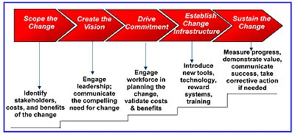

An Organizational Change Process

By completing and defining a change process, a company can be able to document and define the activities which should be managed throughout the transition phase. Moving via such stages assists in ensuring sustainable, long-term, and effective outcomes. Such stages unfold as a company is moving via the transition phase where the needed transformational changes are accepted, understood, tested, and introduced in a way which allows people to let go of their current attitudes and behaviors and create new skills required to sustain desired outcomes of the business.

**Question 2.1**

Shermerhorn, (2018) state that strategy is determining the scope and direction of a company over a long-term period, they suggest that it must establish how resources must be configured to meet needs of the stakeholders and markets. Simultaneously Coccureddu(2014) describes strategy as designed, crafted response to an important and specific challenge.

The effectiveness of the growth of strategy is assessed via organization increasing assets, revenue and profits. The company’s growth of strategy must be effective and must satisfy the major efficiency measures of effective growth that are growing assets, revenue and strategy. The annual results must show more percentage growth in revenue.

The nature of company’s strategy has an impact on the choice and nature of structure. It is important that company’s structure should support and influence its strategy if the desired outcome must be achieved . For instance, when the strategy is stability oriented therefore the choice of structure must be based on proposition in which there is going to be less significant change taking place in the company(shermerhom, 2006: 245-246).

In addition, it means the plans and the operations must be implemented and programmed routinely. To best assist the strategic structure approach , the company structure must be predictable and well defined .On the other hand if a strategy is growth oriented the current situation is becoming more uncertain, fluid and uncertain(shermerhom, 2006: 245-246

 In the management field ,strategic management  includes the implementation and formulation of important initiatives and goals taken by company's top managers on behalf of owners, depending on consideration of resources and an assessment of the external and internal environments where the company operates.

The strategy-making process consists of 3 basic modes: the entrepreneurial mode, in which decisions that are bold are taken by decision-maker who is powerful; the adaptive mode, in which coalition of decision-makers are reacting to environmental pressures with disjointed and small steps; and planning mode, in which analysts are integrating strategic decisions to systematic plans. Henry Mintzberg Califonia Management Review, Vol.16 No2 WINTER 1973, (pp 44-53) DOI: 10.2307/41164491

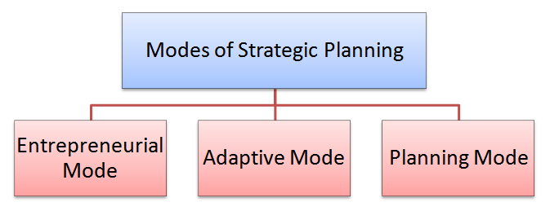

During entrepreneurial mode, strategic plan is made by a single person. That person is taking the full accountability to plan for production department. This means, that person is doing production planning on behalf of the production department. A company must have entrepreneurial skills. Which is person who is good in motivating, organizing, planning, etc. In addition that person is a bold and strong leader.

During adaptive mode, the production manager goes on modifying his plans depending on the changes in the environment. This person is 1st making a huge plan, therefore she is breaking it into small plans. It is made to adapt with a dynamic environment. Therefore she tries to integrate all the plans to do a strategic production plan. In such technique, the production manager is not at peace. She is working in an environment which is not organized. Then , in addition her plan is disorganized. Every company having some adaptive mode reason being companies always adjust to the dynamic environment.

During planning mode, the production manager is making a plan after analyzing the resources and objectives of the company . She cautiously takes into consideration each and every factor prior making a plan. In such technique , her approach is rational. She is giving prime importance to management science. Then , her planning is logical. Company’s modes of strategy making is to plan mode of strategy. The management’s blue print for offering a valuable services or product to clients in a way which can make revenue sufficient to cover the cost and produce attractive profit (Essentials of Strategic management 3rd edition 2013). An organization is muddling via rapidly changing and complex environment with smaller steps. Utilizing the plan mode as starting point on proactive searching for reactive and new opportunities solution of current challenges. Such mode supported by company is normally utilized by big companies that are having enough resources to carry out detailed analysis. With regards to company’s internal system to reach agreement on major goals/ decision in best approach to succeed strategically in an environment which is changing fast. It is operating in an environment which is having enough stability to allow the implementation and formulation of carefully conceived strategies. FNB’s mode is efficient, brief and fast and backed by resource availability (Capital, Skilled, workers experience, New Technology etc).

FNB operating business units in their portfolio that has being independently managed with its own teams, structure and with suitable planning and budgeting back up. FNB is a quirky organization; it has the potential of transforming itself organically and continuously without to buy in an army of change management consultant, or announcing a bunch of top down directives, formulation of complicated strategies and mission statements.

Abandoning control of operations is the best mode of strategy which FNB operated with. The company believed that individuals can act in their best interest and by extension in the company’s best interest when complete freedom is offered to employees. Company’s mode of strategy which was supported strongly to oppose reining employees , informing them how to think, and what to do which is becoming stagnant, bureactic and inflexible. Nevertheless applying force to change is the greatest surest manner to frustrate change. He highlighted on fulfillment at work, FNB is having endless array of wise initiatives and practices geared in increasing individual autonomy. FNB can decide to treat people maturely, by not spoon feeding them: an environment in which people live to go in the morning, he had a believe strongly in giving up control. He did not believe in directing each details since control is the proposition where management is based, abandoning control is harder than it seems. This is resulting to fearlessly, continually, asking why. FNB apparently makes success and money by letting it happen. FNB believes in competitive advantage, FNB is clear regarding why it does what it does.

**Question 2.2**

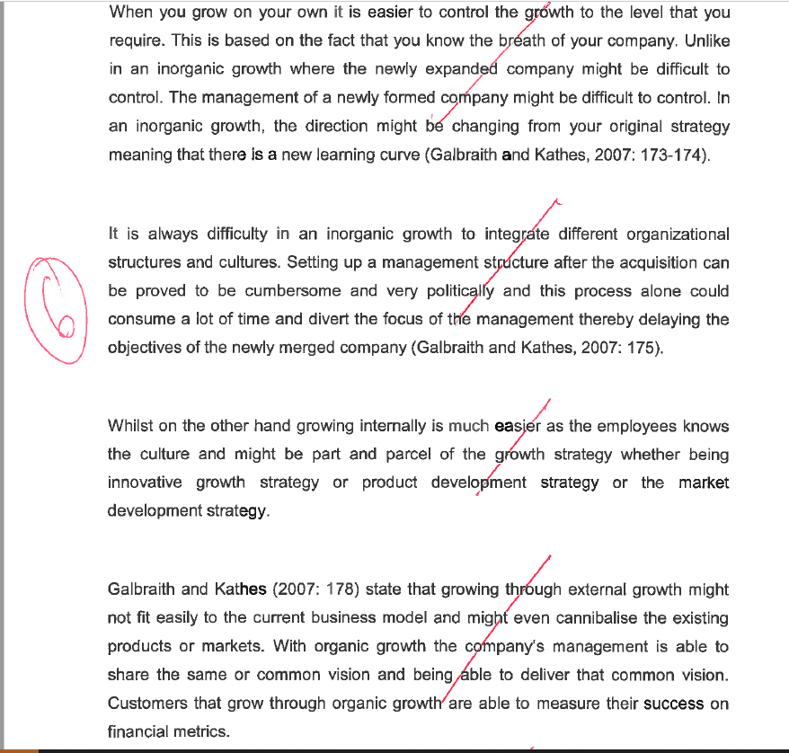

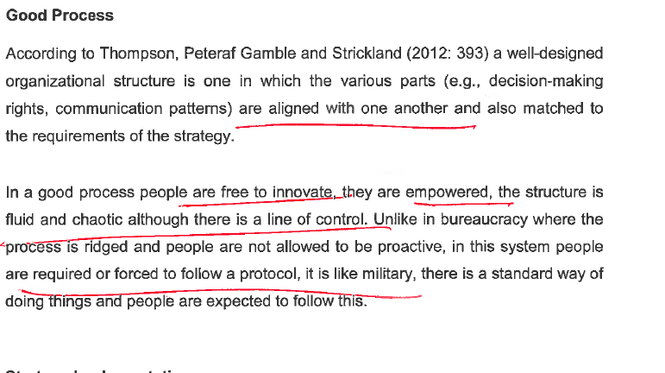

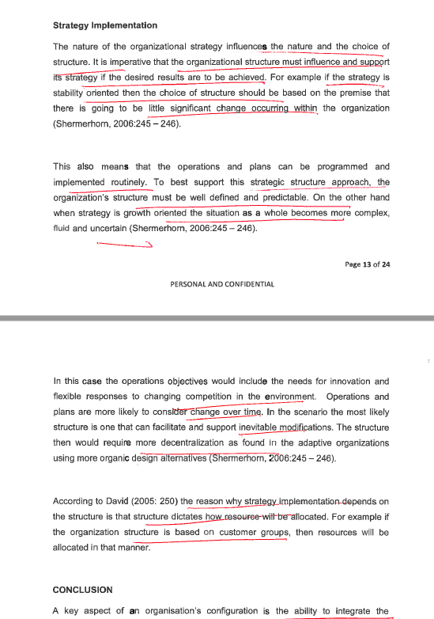

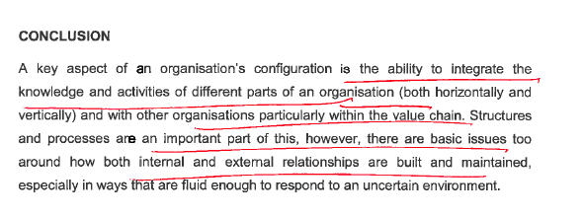

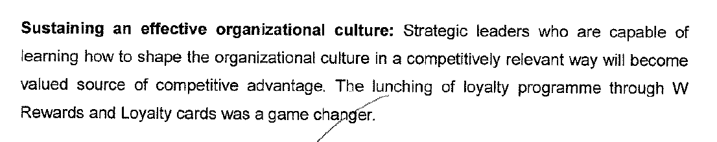

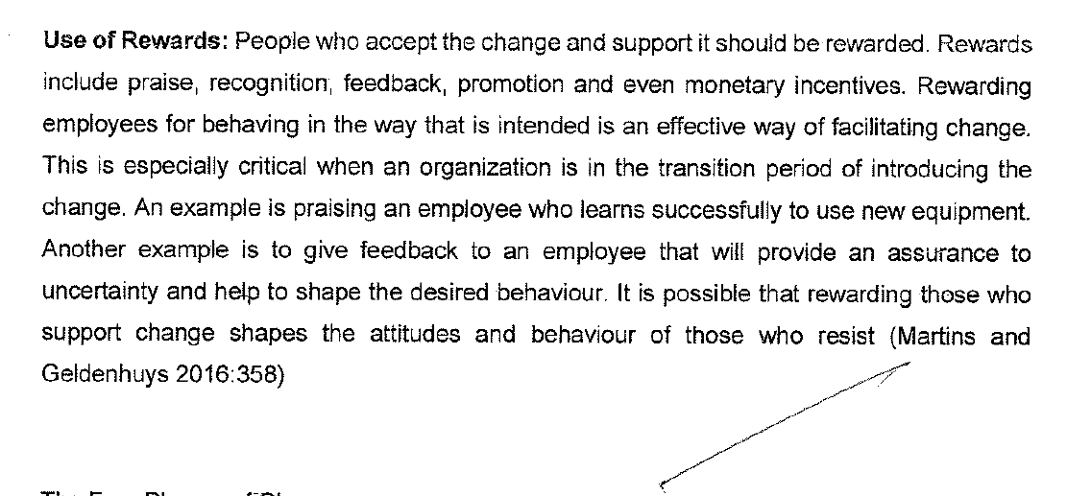

An organizational structure describe how activities like supervision, coordination, and task allocation are directed toward the achievement of organizational aims. Organizational structure has an impact on organizational action and offers the base on which standard operating routines and procedures rest. Organizational structure establishes which individuals are taking part in which decision-making processes, and there to what extent individual views shape the actions of the organizations.

In addition, organizational structure may be considered as the perspective or viewing glass via which individuals view their company and its environment. A company may be structured in number of different ways, based on its goals. The structure of a company can establishes the modes where it performs and operates. Organizational structure enables expressed allocation of responsibilities for various processes and functions to various entities like the individual, workgroup, department and the branch. Organizations must be caring, innovative, flexible and efficient so that it can [accomplish](https://www.bing.com/search?q=define+accomplish&FORM=DCTRQY) a sustainable competitive advantage.

The organizational structure establishes how the company operates or performs . organizational structure term is referring to how individuals in a company are organized and to whom they are reporting to. 1 traditional way of arranging people is by function. Other general functions in a company involve accounting, human resources, marketing, and production. This arranging of specialization is leading to operational efficiency, where workers are becoming specialists in their own realm of expertise.

Simultaneously , the many typical issues with functional organizational structure is that communication in the organization may be instead of rigid, making the company inflexible and slow . Thus, lateral communication among functions is very essential , in order for information to be disseminated not just vertically, also horizontally in the company . Communication in a company with functional organizational structures may be rigid reason being the high degree of formalization and the standardized manners of operation . 1 of the latest organizational structures created in the twentieth century is team and team building, or the related concept of team development. In businesses that are small, the structure of the team may describe the entire organization.

The organizational structure which is created might not [coexist](https://www.bing.com/search?q=define+coexist&FORM=DCTRQY) with the facts, that evolve in operational action. This divergence lowers performance, if growing as an incorrect organizational structure can obstruct cooperation and therefore hamper the completion of orders in due time and within limits of budgets and resources. Organizational structures must adaptive when it comes to processing requirements, focusing on optimizing the input to output and ratio of effort .

Managers must design a suitable reward systems and organizational structures.  Organizational culture contains behaviors and values which is contributing to the unique psychological and social environment of a business . The organizational culture impacts the way people interact. When a company is not possessing a healthy culture or needs other type organizational culture change, changing process maybe daunting. Organizational culture may slow down change efforts, particularly where workers know their roles and expectations which they must play in a company.

It is corroborated by Shermerhorn(2006) who suggests that seventy percent of all change efforts are failing reason being the culture of company's employees. 1 important reason this type of change is complex is that the organizational structures and organizational cultures where they are embedded, are frequently reflecting the "imprint" of previous periods in a persistent manner and show remarkable inertia levels (Schein, 1990).

**Question 3**

CSR is a kind of international private business self-regulation meanwhile when it was practicable to define describe corporate social responsibility as a corporate ethic strategy or internal organizational policy or, that time is gone as different international laws were created and different organizations have utilized their authority to drive it beyond industry-wide or even individual even initiatives.

Meanwhile it was taken into consideration as a part of corporate self-regulation for a while, over the past ten years or so it moved greatly from decisions of voluntary at individual organizations level , to mandatory schemes at international, national ,and regional levels. Considered at the organizational level, corporate social responsibility is normally perceived as a policy of private firm. [Essentially](https://www.bing.com/search?q=define+essentially&FORM=DCTRQY), it should be integrated into and align with a business model to be successful.

With other models, a company’s implementation of corporate social responsibility is going beyond agreement with requirements that are regulatory, and it is engaging in "actions that come into sight to further other social good, beyond the firm’s interests and which is required by law". The choices of 'going beyond', failing to comply, and 'complying' with the law, are 3 distinct strategic choices of an organization. Meanwhile in some areas like labor or environmental regulations, workers might decide to comply with the law, or move beyond the law, some companies can decide to flout the law.

Such companies take on plain legal risks. The nature of the legal risk, nevertheless, is changing if awareness is focusing on soft law. Soft law can cause legal liability especially if businesses is making claims that are misleading regarding some practices, ethical credentials or their sustainability . Generally, businesses can decide to engage in corporate social responsibility for ethical or strategic purposes. From a strategic point of view , the objective is increasing shareholder trust and long-term profits via high ethical standards and positive public relations to lower legal and business risk by taking accountability for actions of the corporate.

Strategies of corporate social responsibility motivate the organization to create a positive impact on the stakeholders and environment which include communities, investors, employees, consumers and others. From an ethical point of view, other businesses can accept corporate social responsibility practices and policies because of senior management ethical beliefs . For e.g., a Chief Executive Officer can believe that a harm which caused to the environment is ethically objectionable. Proponents suggest that companies are increasing long-term profits by operating with a perspective of corporate social responsibility, meanwhile critics suggest that corporate social responsibility is distracting from businesses' economic role.

A research done in two thousand compared current econometric studies of the relationship among financial and social performance, deciding that the contradictory outcome of past researches reporting neutral, negative, and positive financial effect, were caused by flawed empirical analysis and suggested when the research is specified properly. Corporate social responsibility is having a neutral effect on financial outcomes. Critics were questioning "unrealistic expectations" and other times the "lofty" in

corporate social responsibility or that Corporate social responsibility is just an attempt, or window-dressing to pre-empt the government’s role to monitor powerful multinational corporations.

Together with such critical point of view, sociological and political institutionalists decided to be interested in corporate social responsibility in the context of theories of capitalism, neoliberalism, and globalization. Other institutionalists looked at corporate social responsibility as a capitalist legitimacy form and specifically point out what started as a social movement [versus](https://www.bing.com/search?q=define+versus&FORM=DCTRQY) [unrestrained](https://www.bing.com/search?q=define+unrestrained&FORM=DCTRQY) corporate power was changed by companies into a "risk management" and a "business model" device, frequently with questionable outcome.

Ehlers and Lazenby(2015) suggest that Corporate social responsibility is titled to support a company’s mission and also serving as a guide to what the organization is representing for its clients. Business ethics is the applied ethics part which is examining ethical , moral problems or ethical principles which may arise in an environment of the business. . ISO 26000 is the acknowledged international standard for Corporate social responsibility. Public sector companies stick to triple bottom line . It is broadly believed that corporate social responsibility sticks to the same principles, yet with no act of legislation which is formal.

Corporate social responsibility is also called responsible business, conscious capitalism, corporate citizenship, corporate conscience, corporate sustainability, or sustainable business.

Verification

CSR and its resulting efforts and reports must be verified by the buyer of goods and services. The reporting , auditing , accounting, resources offer the basis for consumers to verify that the products are socially sustainable. Because of an increased awareness of the requirement for corporate social responsibility, most industries created their own verification resources. They involve companies like Kimberly Process, International Cocoa Initiative, and Forest Stewardship Council. The UN Global Compact offers frameworks not just for verification, but as well as to report violations of human rights in corporate supply chains.

The growth of ethics training within companies, part of it required by regulation of government, has assisted with the spreading Corporate social responsibility. The purpose of this training is to assist workers to make ethical decisions if the answers are not clear. The more direct advantage is lowering the possibility of damaged reputations, fines, and "dirty hands" for breaking moral norms or the laws . Companies get increased workers pride and loyalty in the company .

Community involvement: it may involve to raise money for engaging in fair trade practices,

supporting local economic growth, employing local workers, sponsoring local events, providing volunteers, local charities, etc.

Common Corporate social responsibility actions involve:

Ethical marketing: Organizations which ethically market to buyers place more value on their clients and respect them as individuals who are ends in themselves. Organizations are not trying to falsely or manipulate advertise to potential buyers. It is essential for organizations which are trying to be viewed as ethical.

Environmental sustainability: this may include 'greener' supply chains, reusable materials, renewable energy, water management, waste management, recycling, supporting Environmental Design and Leadership in Energy building standards and lowering paper use.

Human capital enhancement: Organizations offer more resources for capacity building of local workers , involving language classes, adult basic education, professional and technical training.

Other national governments are promoting environmentally and socially accountable corporate practices. The heightened government roles in corporate social responsibility has facilitated the creation of many corporate social responsibility policies and programs. Different governments in Europe decided to push organizations to create sustainable corporate practices. Additionally Germany determined the German Trade Union Confederation in nineteen forty nine to [farther](https://www.bing.com/search?q=define+farther&FORM=DCTRQY) promote corporate social responsibility; the confederation is representing the interests of forty five million employees in Germany. Wage , job security are growing with the industry growth are important aspects of collective bargaining in the German labor system.????

According to the corporate social responsibility Journal, the generation of millennials across the globe assist propel brands toward social responsibility. Most millennials are trying to conduct business with trademarks and organizations which employ ethical business practices, sustainable manufacturing processes, and pro-social themes. Nielsen Holdings has published its Annual Global Corporate Sustainability Report in twenty seventeen focusing on sustainability and as well as global responsibility. Nielsen's 2015 report indicated that sixty six percent of buyers can spend more on products which come from brands that are sustainable. The other eighty one percent are expecting their preferred corporate institutions to [disclose](https://www.bing.com/search?q=define+disclose&FORM=DCTRQY) in public their statements regarding corporate citizenship?????

Since the nineteen sixties , CSR drew awareness from a group of stakeholders and businesses . A broad selection of definitions were created yet with little consensus. Part of the issue with definitions has increased because of different interests that were represented. A government official can view it as voluntary regulation, an NGO activist may see it as 'greenwash' , while a business person can define corporate social responsibility as a business strategy.

" Additionally, disagreement regarding definition can arise from the disciplinary approach."

CSR is defined by Sheehy as "international private business self-regulation." Meanwhile Carroll???? did not define corporate social responsibility, yet easily arguing for classification of activities,

Sheehy ?????created a definition different after the science philosophy the philosophy branch of utilized it for defining phenomena. Carroll decided to extend CSR from the legal responsibility and traditional economic to philanthropic and ethical responsibility to respond to the growing worries on ethical issues in businesses, is sharing a belief which states that marketing local products can obtain consumer trust. Nevertheless, environmental efforts received negative perspectives with a belief that it will have an impact on client’s service .

Oppewal et al??.  discovered that not all activities of corporate social responsibility are attracting consumers. They suggested that retailers are concentrating on 1 activity. Becker-Olsen???  discovered that when social initiative are made by the organization, it is not positioned with some organization goals it can result in a negative impact. Additionally Mohr et al.  and Groza et al.??   emphasize the significance of reaching the consumer. Other commentators identified a difference among the Anglo-Saxon, the Continental European And the Canadian approaches to corporate social responsibility. It is said that in in South Africa it is making a positive contribution to social needs like education and health care; for Germans it offers secure employment; and for Chinese consumers, a socially responsible company is making high-quality, safe products.

Corporate social initiatives :corporate social responsibility involves different kinds of corporate social initiatives: Organizations are not having a profit motive if they take part in in community volunteering and corporate philanthropy. Simultaneously, the corporate social initiatives that are not yet used may be e.g. of cause marketing, where there is both a profit motive and societal interest.Corporate social responsibility can be a separate unit reporting to the board of directors or the CEO, can be based within the public relations departments or business development of a company, or human resources. An engagement plan may help in reaching intended audience. A CSR team or individual plans the objectives and goals of the company. Like any other company’s activity, a defined budget is demonstrating scales and commitment of program's relative importance.

.Social accounting is a communication of environmental and social impact of an organization’s economic actions to specific interest groups to society at large and in the society. Social accounting is emphasizing notion of corporate responsibility . Crowther???? Describe social accounting as "an approach of reporting company’s activities that stresses the requirement to pinpoint socially relevant behavior, the establishment of those to whom the organization is responsible for the development of suitable reporting techniques and measures, and its social performance . "Reporting standards and guidelines are serving frameworks for social reporting, auditing and accounting:?????????/

In the twenty first century, CSR in the supply chain attracted awareness from stakeholders and businesses. Company’s supply chain is a process where different companies including logistics providers , customers and suppliers are working together to offer a value services and package of products to the end user, which is the client.

Corporate social irresponsibility within the supply chain has significantly impacted the companies reputation , which leads to more cost in solving issues. For example , incidents such as the twenty thirteen Savar building collapse, that killed more than one thousand individuals, has pushed organizations to take into consideration the effects of their operations on the environment and society . Simultaneously, the twenty thirteen scandal of horse meat in the UK had an impact on many food retailers, involving Tesco, which is the biggest retailer in the UK, which lead to dismissal of the supplier. CSR from both the retailers and the suppliers had a huge impact on the stakeholders that lost trust for affected business entities, and besides a fact that other times this is not directly tackled by the organizations, they are becoming responsible to their stakeholders. Such surrounding problems are prompting supply chain management to take into consideration the CSR accountability context. Wieland and Handfield ???? state that organizations that require to involve social responsibility in their reviews of component quality. They emphasized the utilization of technology to improve visibility allover the supply chain.

Ethical Quote is used to track reputation of the world's biggest organizations on Corporate Social Responsibility, Governance, Social, Environmental, sustainability and ethics.

**References:**

David, F.R. (2013). Strategic Management- Operations and Cases 10th Edition.

Ehlers, T and Lazenby, K. (2007). Strategic Management Southern African concepts and cases Second edition Van Schaik.

Hill, W.L. and Jones, G.R. (2009). Strategic Management-An Integrated Approach.Delhi-Biztantra

Ritson, N. (2013). Strategic Management. 2nd Edition. Neil Ritson and bookboon.com

Hughes, M. (2011). Change Management in Organisations. Delhi-Jaico Publishing House.

Hoisington, S.H and Vanesswaran, S.A (2015). Implementing Strategic Change Tools for Transforming an Organisation. New Delhi-Tata McGraw-Hill Publishing Company Limited.

Passenheim, O. (2010). Change Management. 1st Edition. The ebook company.

Rao, P.S. (2010). Strategic Management. Mumbai-Global Media.

Shermerhorn, J.R. (2018). Management. 5th Edition. Ohio University-Wiley.

Schein, E. H. (1990). Organisation Culture. American Psychologist. February 1990

///////////////////////

**11.1.2 STRATEGIC AND CHANGE MANAGEMENT [100]**

**QUESTION ONE [60]**

Read the following article and answer the questions that follow

**Can SA’s new challenger banks knock out the ‘big four’?**

For two decades, SA’s banking sector has remained largely the same. The advent of Capitec, in 2001, showed that customers were desperate for something different. Now, three new banks — all backed by powerful SA business personalities — are opening their digital doors, offering something entirely different. So what can they offer that’s new, and how much of a threat is this for the ‘big four’ banks?

**28 MARCH 2019 STEPHEN CRANSTON**

Financial services used to change slowly. Twenty years after Douw Steyn launched the direct-to-consumer insurer Auto & General in 1985, insurance was still largely sold through brokers, and index funds still accounted for a tiny portion of investment assets.

Banking changed even more slowly. More than 25 years after the launch of the internet, most banks still distribute a large portion of their products through a branch network. These branches will still be perfectly recognisable to anyone visiting SA for the first time in 30 years. None of the big banks will rock the boat; they want to protect their collective income. That era has come to an end. In the past few months, three new banks have launched with a leaner, cheaper business model that will change the face of SA banking — Discovery Bank, TymeBank and Bank Zero.

It’s been a long time coming. After Saambou and Fidelity Bank collapsed in the early 2000s, the SA Reserve Bank was for a long time reluctant to let new banks open. But these three new banks are backed by formidable business personalities with deep pockets.

Discovery Bank is part of the wider group run by CEO Adrian Gore, which began as a health-care company in 1993. Discovery boasts Remgro associate Rand Merchant Investments (RMI) as its anchor shareholder.

Tyme Bank is controlled by African Rainbow Capital (ARC), an investment company controlled by the eclectic Ubuntu-Botho group headed by Patrice Motsepe. As the Forbes rich list has it, Motsepe is one of the 1,000 wealthiest individuals in the world, with a fortune of $2.4bn. Before it was bought by Motsepe’s company, TymeBank was owned by the Commonwealth Bank of Australia (CBA), one of the world’s top 10 retail banks.

As for Bank Zero, the most entrepreneurially based of the three, it shows how far the Reserve Bank has come that it got the green light. Bank Zero is run by a maverick group of former FNB executives, most of them with strong technology backgrounds, with a few family and friends as shareholders. The chair and figurehead is the former FNB boss Michael Jordaan, based in Stellenbosch.

Somewhat ironically, Jordaan is Motsepe’s partner in the data-only telecom network Rain. The Bank Zero CEO, Yatin Narsai (former head of FNB retail), runs the business day-to-day from Bryanston.

Discussing the rationale for the bank in an interview with the *FM*, Narsai says SA ranks among the five countries with the highest bank fees in the world. "This is intolerable in such an unequal society, but then the rest of the bottom five were similarly unequal countries in Latin America," he says.

No-one can ignore the competitive threat of cheap banking. Narsai says he personally will save R2 000 a month from his personal and business accounts, when Bank Zero goes live and he can move accounts. "Low fees will become the new normal and I hope that penalty fees will disappear altogether," he says.

The question, however, is what the existing big four banks — FNB, Standard Bank, Absa and Nedbank — will do to counter the threat. "The big banks ignored Capitec in the early 2000s," says Louis Chetty, head of financials at Stanlib, "and lost considerable market share. I am sure they will not make the same mistake again."

Capitec has more than 10-million customers, who will have been enticed, in part, by the much lower cost of banking. And yet the big four still have 83% of all bank deposits in the country and 92% of all mortgages, which shows how concentrated the market still is.

Harry Botha, a banks analyst at Avior Capital, says it could take three to five years for the challenger banks to make material inroads into the large banks’ earnings.

**Discovery, TymeBank and Bank Zero** are pursuing a branchless model, with their apps being their shop window. This means SA isn’t far behind the rest of the world: the first app-only current account in the UK was introduced by Starling Bank just two years ago. Perhaps if the Reserve Bank had been more open-minded, SA could have beaten them to the punch.

But, globally, this is the trend. No-one should have been surprised by Standard Bank’s announcement two weeks ago that it was closing up to 15% of its branch network — or 91 branches. Botha says Standard’s natural market share has fallen thanks to the success of Capitec and FNB, in different parts of its client base.

Standard Bank CEO Sim Tshabalala called it "realigning the retail and business banking model to the changing needs of customers". And, of course, the convenience of digital banking makes so much more sense than travelling to a branch and queuing

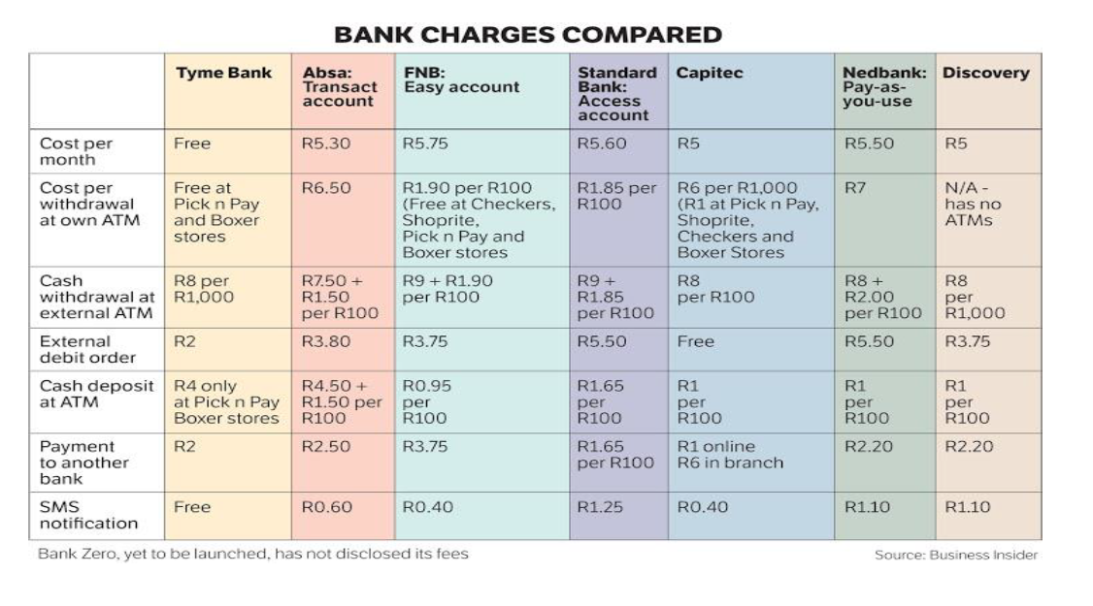

TymeBank chair Coen Jonker tells the *FM*: "The banks have done their best to protect their legacy income streams for years, and the transactional fees on simply taking money in and out of accounts is the hardest to justify. As new banks we won’t have that legacy to defend."

The big four banks have long operated as if they were an informal cartel. Even the one entrant in the past 20 years to grow to large-bank status, Capitec, has adopted a traditional branch-based distribution model.

Only Investec has operated without branches — but to a narrow spectrum of high net worth clients. To see what sort of riches are up for grabs, consider Capitec’s trajectory. In its first year on the JSE in 2002, Capitec made revenue of R270m, with just a smattering of clients. By August 2018, it was clocking up R9.3bn in operating income with its 10.5-million customers. Its share price has reacted accordingly: R10 000 invested in the bank at the beginning would now be worth R7.2m.

Fees were a big part of this success. Capitec has a nominal monthly fee of R5, with R1 charged for each digital transaction. Cash withdrawals are more expensive at R6 for the first R1 000 at a Capitec ATM, or a flat R1.60 at till points of retailers like Pick n Pay or Shoprite. As many of Capitec’s transactional clients earn interest of 5% on their deposits, they often get more money coming in than they pay in fees.

These new banks would appear, in part, to be targeting that market. However, Chetty says clients who have a loan with Capitec are unlikely to move their transactional accounts to the new banks in a hurry. "Banking will never be free," says Capitec CEO Gerrie Fourie in an interview with the *FM*. "Even at Capitec, we have a high fixed-cost base."

Interestingly, Capitec is the only bank that is actually increasing its branch footprint, even though 2.2-million clients have migrated to the app and 4-million to the USSD (SMS-based) transactional platform.

At the moment, Capitec has 840 branches, though many are smaller than those of the big banks. The branches have proven invaluable as the predominant sales point for the half-a-million Sanlam funeral policies sold through Capitec over the past year.

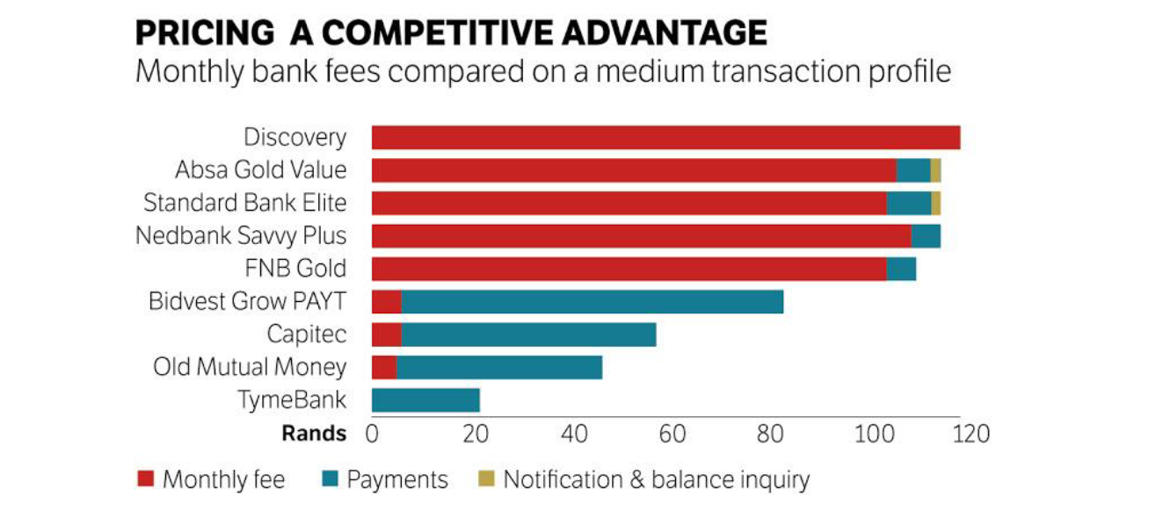

Avior’s Botha says SA is still a long way from a zero-fee banking regime, even among the new entrants. But fixed monthly fees and charges for electronic transactions could come to an end sooner rather than later.

Discovery Bank will charge both sets of fees — at least for now.

Gore says banks operate on three legs: fees, interest and rewards. Some banks (like Capitec and the other newcomers) will offer competitive fees and attractive interest on accounts but no rewards programme; while the large banks pay little or no interest on current accounts but have decent rewards programmes.

Gore says Discovery will not attempt to beat the market on fees, for a combined current account and credit card.

Discovery Bank’s lower-income clients (those earning less than R300,000 a year) will pay between R149 and R186 a month in fees; middle-income customers will pay between R213 and R240; and higher-income clients will pay between R275 and R440. For a pure transactional account the fee will be R60 to R120, but as Discovery has no ATMs, cash withdrawal fees will be higher.

But if it won’t compete on fees, Discovery Bank will be second to none with its Vitality Money rewards programme, and the sophisticated way in which it encourages the right financial behaviour.

Discovery Bank will match Capitec’s 5% interest rate on positive current account, and add an extra 1.5% for those in the top tier of the Vitality programme.

The three new banks are not just aiming for the tech-savvy. TymeBank’s former parent, CBA, has a larger market cap than the entire SA banking sector, though it took a softly-softly approach to the new bank. Even before Tyme was registered, it offered money transfer services from Pick n Pay.

Though Tyme doesn’t have any of its own branches, it will have 750 points of sale through Pick n Pay and Boxer stores. This gives it reach into the main urban areas, as well as the rural areas where few banking services are typically available. Boxer customers are more likely to be unbanked, so could prove the most fertile hunting ground for Tyme.

Most transactions are free if carried out at Pick n Pay or Boxer, and cost only R2 if done elsewhere, and the bank pays up to 10% interest on positive balances. TymeBank has such low costs because it is cloud-based and highly scalable, and has minimised the bells and whistles. Incredibly, there are just 125 staff keeping the bank running. Clients can join through the TymeBank website, but by far the most popular recruitment tool has been self-service kiosks, which provide a new card within five minutes.

CEO Sandile Shabalala says the bank will start offering loans next year. It plans to offer keener lending rates because, like Capitec, it will be able to cross-subsidise its transaction and deposit books from its loan income. The tipping point for Tyme, at which it becomes profitable, is 2-million customers and 700,000 loans.

It is almost an accident that Motsepe’s ARC took full control of the bank after CBA pulled out suddenly to retreat to its home market and cut exposure to emerging markets.

Johan van Zyl, the co-CEO of ARC (and chair of Sanlam) says he was pleased CBA was the controlling shareholder while the bank was being registered because it is a bureaucratic, by-the-book organisation with huge experience of banking regulation.

"We would like to bring in an equity partner as we prefer to hold minority positions in companies, not the 73% we currently hold, but it is not an imperative," he says.

Van Zyl says the Reserve Bank does not want TymeBank to become a Sanlam group company as it wants to keep banks and insurers as separate as possible. TymeBank, he says, will ride the wave away from cash transactions to digital payments.

"We expect the amount of cash in the system to be cut back by two-thirds over the next three years. Increasingly shareholders in the Ubuntu-Botho group find carrying cash dangerous. We were able to issue 1-million cards to members of the Zion Christian Church to facilitate cashless transactions," he says.

For now though, Pick n Pay stores are more than happy to offer excess cash to TymeBank customers at no charge. The retailer’s deputy CEO, Richard van Rensburg, says Capitec also recommends its customers draw money at Pick n Pay tills because it is far cheaper than using an ATM. And a central feature of TymeBank is its access to the information gathered by Pick n Pay on the 11-million members of its Smart Shopper programme, which provides rewards points on all purchases, not just at Pick n Pay. And unlike Discovery, that benefit is not confined to healthy foods. In a much less judgmental way, all purchases qualify.

You might have expected Pick n Pay to have cold feet after the failure of its Go Banking venture with Nedbank in the mid-2000s. But Van Rensburg argues that Go Banking offered similar services to Nedbank, whereas TymeBank has developed products exclusively for digital clients. He says he would not try to set up a bank as a subsidiary of a retailer again, but an alliance between a retailer and a bank makes sense.

Pick n Pay CEO Richard Brasher is also the founder of Tesco Bank, which is owned by the UK’s largest supermarket chain.

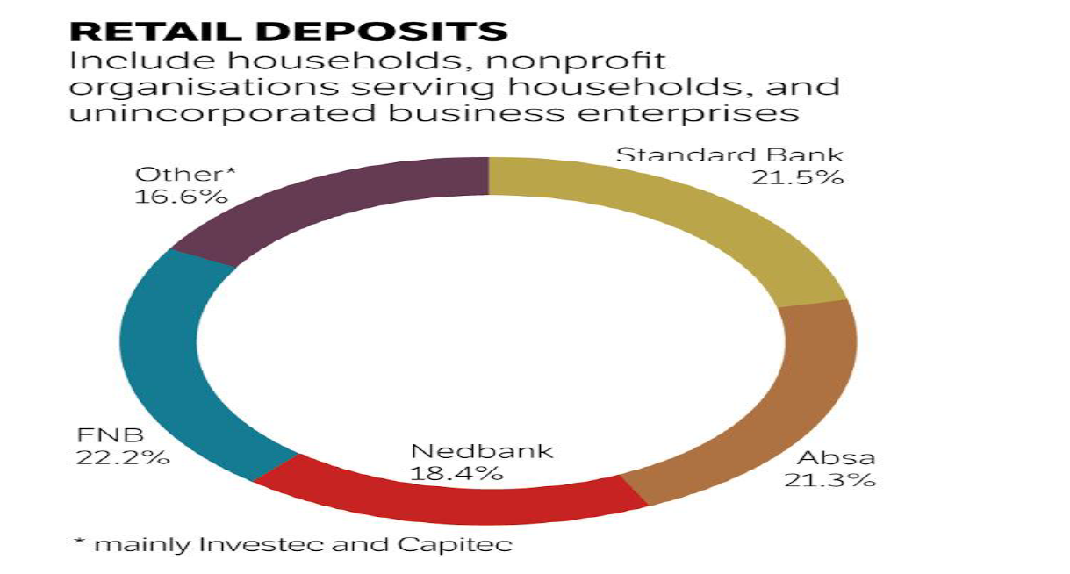

Motsepe and his team are facing some other strong personalities over at Bank Zero. Jordaan may just be the nonexecutive chair of Bank Zero, but with his deep knowledge of new technologies, the market seems confident that his bank will be impressive from the start.

Narsai, as head of FNB retail, is even more deeply entrenched in IT than Jordaan. "I am impressed that TymeBank has signed up 120,000 customers in a few months," he says. "[It shows] there is pent-up demand for a good-value, no-frills bank account. But we will be offering considerably more sophisticated functionality."

Other FNB renegades at Bank Zero are chief risk officer Lezanne Human (who also moonlights as the informal head of public affairs), and co-founder and CFO Liné Wiid. Bank Zero, as a mutual bank, will focus on deposits and transactional banking and will not offer loans for the foreseeable future.

"The intention is to keep capital as lean as possible, and considerable capital is needed to roll out loans," says Narsai. It will also focus on the business banking market, where margins are still chunky.

Narsai promises a "creative" solution for clients who might go modestly into the red. But he also hopes to nurture a savings culture through attractive interest rates. Initially, the team had planned to focus on high-margin areas, particularly remittances from neighbouring countries, but they soon realised they had the capability to launch a full-service bank.

Jordaan tells the *FM* that Bank Zero, launching in the second half of 2019, will make money through the interest it charges, fees on third-party transactions and commissions on prepaid products such as airtime. "But with our low break-even you can expect lots of zeros where other banks charge fees," says Jordaan.

Mark Elliott, president of Mastercard Southern Africa, says he is working with Bank Zero to develop a new kind of card that can deliver better security, which is appropriate for today’s increasingly mobile and digital customers.

Bank Zero also keeps costs down by using the cloud, but the heart of the business will be its IBM LinuxOne enterprise server, which uses (free) open-source software. Perhaps Bank Zero’s most serious competitor, at least in the small to medium business sector, could be Mercantile, once it is revitalised under Capitec’s ownership.

Narsai says most banks opt for off-the-shelf IT systems, where both the risk and capital requirements are significant. Bank IT managers naturally gravitate towards packages conforming to past norms, which tend to create a "me too" starting point.

"We have preferred to build our platform to clearly defined bank specifications. We are very comfortable doing this with our deep expertise. And we can design from the ground up for today’s issues such as regulation and cybercrime," he says.

Capitec’s Fourie warns, however, that while new fintech technology providers might be adding value, they fall short on two issues — handling volume and maintaining security. It’ll be interesting to see how Bank Zero navigates this.

**For Jordaan, it’s a natural evolution**. Now living in Stellenbosch, he became CEO of FNB when he was just 36, creating an institution that grabbed plaudits as "the world’s most innovative bank" in 2012.

He says he thrived in the entrepreneurial FirstRand culture fostered by the three founders — GT Ferreira, Laurie Dippenaar and Paul Harris — who embraced start-up ventures such as Discovery and Outsurance. This inspired him to become a backer of small business.

Jordaan left FNB in 2013, because he says 10 years of commuting from Stellenbosch to Johannesburg was enough. There was no love lost between him and Discovery (another FirstRand subsidiary at the time), which he called the enfant terrible of the group and a disrupter, in the days when that was still a swear word.

Jordaan says all the Bank Zero shareholders are active as executives or active directors, with skin in the game.

"Without a big corporate shareholder, we can take a much longer-term view," he says. "We have a cohesive strategy to bring significant customer benefits without the pressure to produce short-term profits."

Mutual banks might have a bad name after the collapse of VBS last year under a mountain of fraud, but one of the benefits of the structure is that it allows customers to become shareholders.

If Bank Zero’s model is simple, Discovery Bank’s is the opposite.

The launch included a 70-page "thought leadership" document with chapters on such warm and fuzzy notions as "shared value", "behaviour change" and "people-centric" design. Still, Discovery Bank’s CEO, Barry Hore, promises that the app will be simple to use, once clients get used to it. "It is multifunctional, a bank branch in the palm of the hand," he says.

Interesting features of its model include Discovery Pay, which allows clients to pay any other client without needing to register the person as a beneficiary. Pharmacy co-payments can also be automatically deducted from the bank account.

To date FNB has been the leading bank for innovative features, such as registering as a customer using a selfie from your phone. But Hore says the Discovery platform will ensure that bank customers never need to visit a branch, even to open an account, and from day one cardless capabilities such as Samsung Pay, Garmin Pay and FitBit Pay will be available.

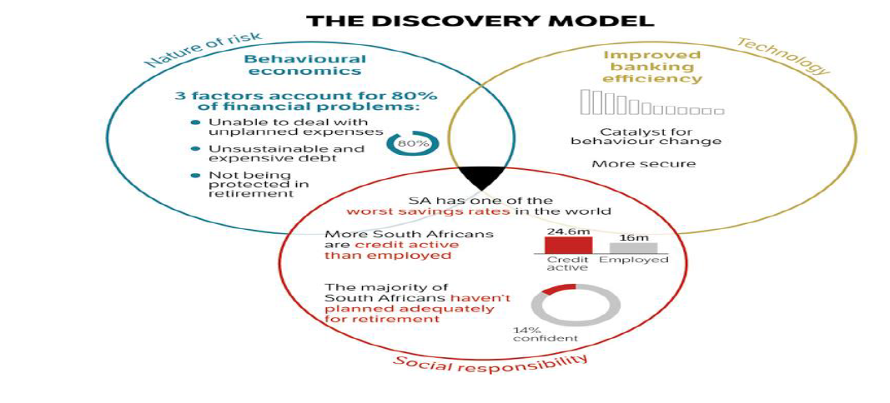

The Discovery Bank app went live this week, and the first stage is to migrate former clients of Discovery Card (which was backed by the FNB platform) into the bank. It will necessarily be a slow process to avoid anything going wrong. But by June, the first 10,000 clients are expected to be onboard.

Discovery’s advantage is that unlike the other two new banks, it is already a household brand. It also has a good chance of capturing the majority of its credit card clients (bought back from FNB) and a sizeable slice of its medical aid and insurance clients. Already, the group’s Vitality programme has cult status among some, and if you believe

their marketing, physically fit people are less likely to be financially irresponsible. And the ability to cross-sell was an important reason for setting up the bank in the first place.For those who are on the main Vitality Health programme (Discovery medical aid members or life policyholders), and who hold a Discovery bank account, there will be plenty of benefits. For example, those on the higher Vitality status can get free membership at Virgin Active or Planet Fitness gyms, while the discounts for flights on Kulula can be up to 75%. There are also cash-back rewards for healthy food at Woolworths and Pick n Pay.

Hore insists you don’t have to be a gym bunny to get a good deal from the bank — people with no other Discovery product still get a 25% discount on fuel and healthy food. But these are the frills. Discovery has not yet revealed how it plans to recoup the considerable start-up costs. It has spent close to R4.5bn between developing the bank systems (which, like those of Standard Bank, are based on SAP products) and buying back the Discovery credit card from FNB. Gore says Discovery could not opt for a simpler cloud-based solution, as Tyme Bank has done, because its system needs to accommodate the complex links between the bank and its Vitality programme and the company’s health, life, investment and insurance businesses.

This suggests it will take longer for Gore’s bank to make a profit than either of its more nimble competitors, Bank Zero and TymeBank, and the marketing spend will be higher. Discovery estimates it could take five years to turn profitable. Gore says the bank has been built from the ground up with the latest technology and features — including the most advanced fingerprint and facial recognition systems — as well as the ability to add accounts with a few clicks. But he is pinning much hope on the behavioural approach and rewards system, which he believes is the differentiator.

Gore challenges the view, expressed by FirstRand CEO Alan Pullinger recently, that SA’s banks already use a behavioural approach to assess the quality of their clients when it comes to risk. "We don’t agree," says Gore. Most banks reward clients for taking out more products, which specifically increases their debt and credit levels, he says. This means there are now 8-million more credit-active consumers than employed people — a big risk to society.

"We don’t push products, but encourage [customers] to follow key behaviour to secure financial health. They get the tools to help them through the Vitality Money programme," he says. Still, it’s clear that Discovery Bank won’t be matching the costs of TymeBank and Bank Zero item-for-item, at least for the average client. Instead, its sales proposition is to help clients achieve financial health and then reward them. Hore says it will set personalised goals based on an individual’s circumstances, and will have a wider product range on day one than its rivals. Discovery will offer credit, transactional products and savings products.

The bank will also offer dynamic interest rates. This means that its best customers (not necessarily its richest), could pay 6% below the market rate for debt and earn 2% more for savings. Hore says Discovery’s "shared value" approach is not meant to punish those who don’t achieve perfection, but rather to nudge people to make better choices.

If the bank takes off as Gore expects, there is plenty of scope to export this model too. While Gore says the bank will start as a purely SA venture, he isn’t ruling out exporting a banking version of the Vitality Shared Value model at a later point.

Discovery Bank might be branchless, but it will have a handful of hi-tech walk-in centres. It will rely heavily on its network of agents and brokers to push clients towards the bank.

This network of brokers and agents is something that TymeBank and Bank Zero don’t have. While Bank Zero is entirely app based, Tyme at least enjoys some advertising through its black and yellow machines at Pick n Pay stores, and has started flighting prime-time TV adverts to lure clients. Chetty says Bank Zero needs to develop a brand and requires a professional marketing campaign to do it. None of the team has marketing experience except for Jordaan, and that won’t be enough to build a brand — even with his Steve Jobs-style charisma.

While there’s electricity in the air in the banking sector for the first time in years, it won’t be a one-way bet. There is, after all, the cautionary tale of SA’s first digital bank, 20Twenty, which launched in 2001 using Saambou as the backbone. 20Twenty never got to critical mass, with just 40,000 clients, and closed in 2006.

But the fact that TymeBank already has 120,000 clients is evidence that perhaps the time is now right. Narsai says that while 20Twenty had a huge marketing budget and a limited range of products, the architecture was quite primitive by today’s standards and the benefit from lower fees was limited.

**WHAT IT MEANS**

Three new banks are set to change the face of SA banking with a leaner, cheaper business model

Back then, there were fewer smartphones (it was the age of BlackBerry) and the environment wasn’t inherently as friendly for digital products as it is today. 20Twenty, for example, operated largely through a call centre, and the customer experience was often indifferent.

Though price alone might not be enough to propel the new banks into profit, they are launching at a time of considerable unhappiness over bank fees. It is easier than ever, through apps, to compare fees. Until now, none of the large banks has been prepared to jeopardise their lucrative income stream from transactional fees with a price war. But now they will have no choice.

Says Botha: "The big banks will cut fees, but only gradually — they need to cut costs first before they can afford to do so. "At least, in most cases, the big four banks still own the relationship with the customer and can persuade them to stay. Botha says they can be expected to increase their credit spreads on loans to make up for the lost fee income. Capitec is likely to be the least affected, says Chetty, given that it already has a competitive current account with low fees.

This means it will be the big four who will bear the brunt of the industry disruption. Already they’re scrambling, introducing innovations like joining up with just a selfie. But they may have left it too late to ride the tsunami of change.

**https://www.businesslive.co.za/fm/features/cover-story/2019-03-28-can-sas-new-challenger-banks-knock-out-the-big-four/**

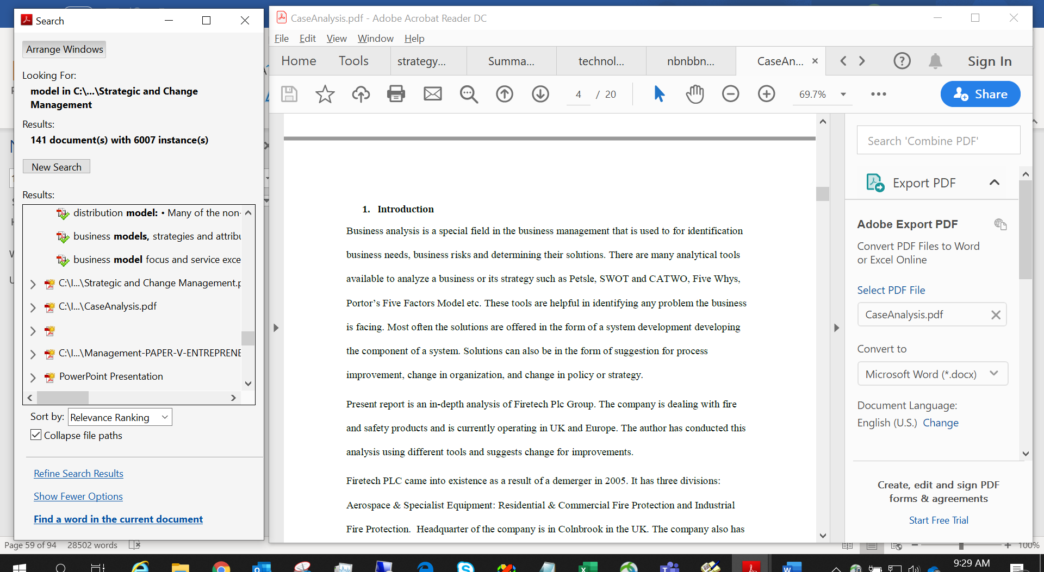

Ccccccccccccccccccc

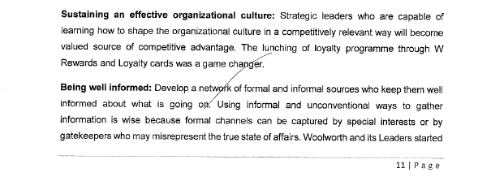

UUUUUUUUUUU



UUUUUUUUUUUUUUUUUU



Sssssssssssssssssssssss



SSSSSSSSSS

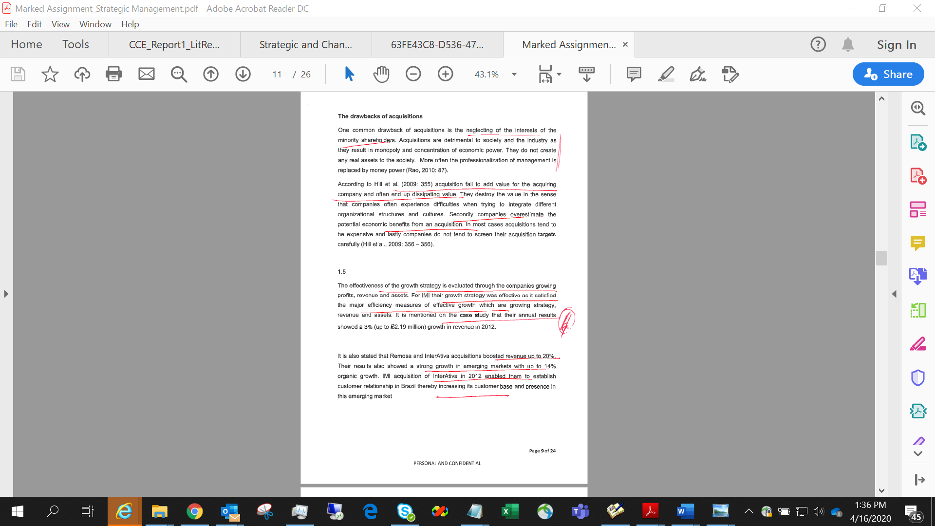

Ssss

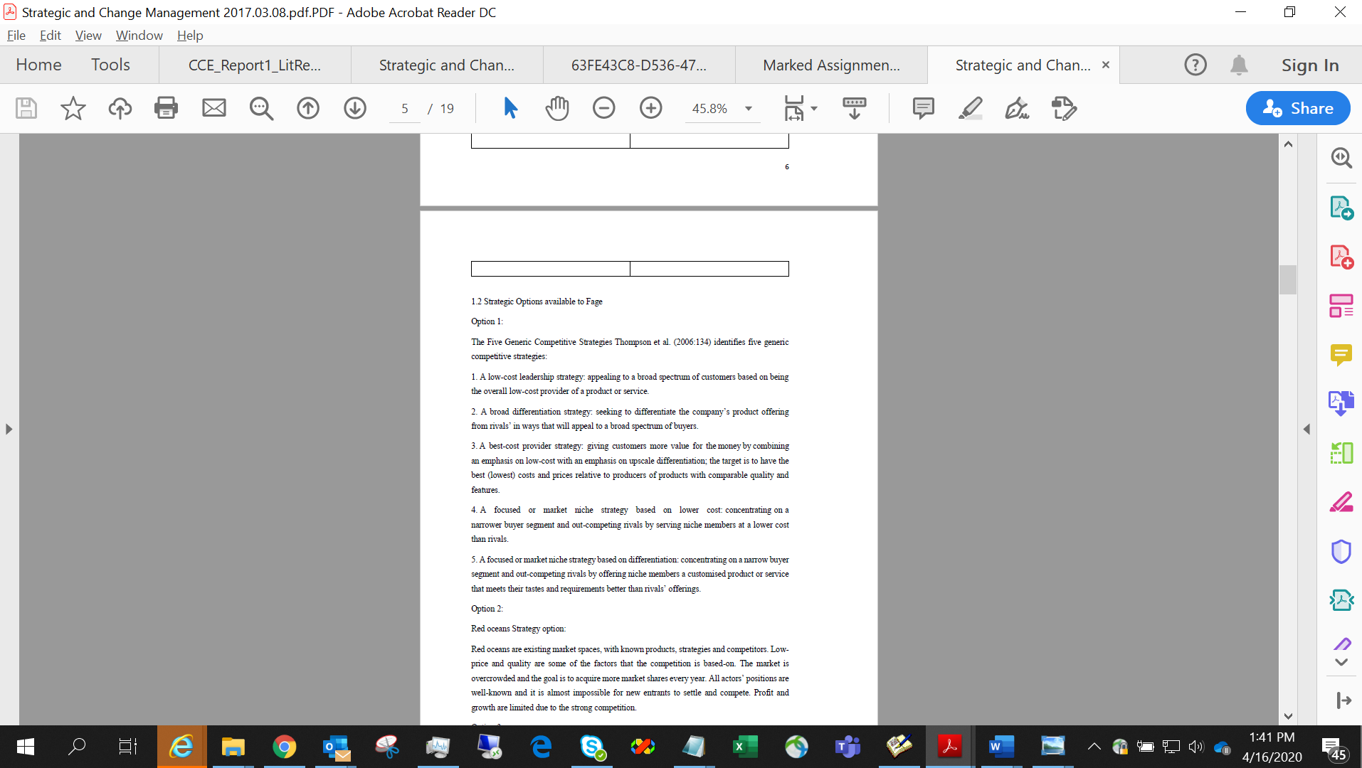

SSSSSS

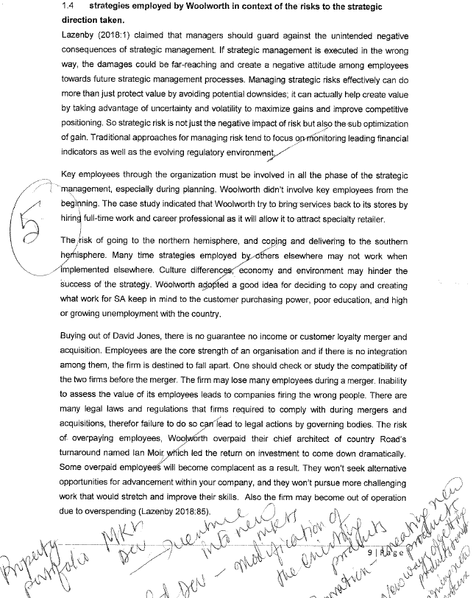

UUUUUUUUUUUUUUUUU

3.3

Schein (1990:111) provides one of the most widely quoted definitions of organisation culture as “(a) a pattern of basic assumptions, (b) invented, discovered, or developed by a given group, (c) as it learns to cope with its problems of external adaptation and internal integration, (d) that has worked well enough to be considered valid and, therefore (e) is to be taught to new members as the (f) correct way to perceive, think, and feel in relation to those problems.”

Bhattacharyya (2011: 268 - 269) emphasizes the following organisational culture change process: ƒ Identify the core values and beliefs ƒ Consider the subcultures within the 19

organisation ƒ List out the incongruence ƒ Establish new behavioural norms ƒ Repeat these steps over a long period of time.

Models of Organisational Change Kanter et al (1992) identified the following themes as the basic assumptions of most change models and/or frameworks:

Awakening the organisation to a new reality and disengaging it from the past. Recognising that the old way of doing things is no longer acceptable. The need to create and embrace a new vision of the future by the organisation. The need to unite behind the steps necessary to achieve the stated vision. The need to solidify’ or ‘refreeze’ the new attitudes, practices and policies. There are as many models of change as the attempts that have been undertaken to change organisations over the years.

Manifestations of Culture Schein 1990) identified three fundamental levels at which the culture manifests itself:

1. the observable artefacts: including the physical layout, dress code, manner of address, the smell and feel of the place, its emotional intensity, company records, products, statements of philosophy, and annual reports;

2. the values: including norms, ideologies, charters, philosophies, why certain observed phenomena happen the way they do;

3. the unconscious assumptions: the taken-for-granted, underlying, and usually unconscious assumptions that determine perceptions, thought processes, feelings, and behaviour.

Culture refers to beliefs, values and attitude held by management and their employees (Passenheim, 2010). Any business like Nokia may have inherent attitudes which do not support change. A change of strategy, structure and technology make it necessary for people (employees) to change their knowledge, behaviour and attitudes. If this is not implemented correctly this can inhibit cultural change in an organisation. Through better training on strategic changes to be implemented in an organisation and allowing employees to accept and adopt to the changes can help facilitate change in an organisation. There are steps to be followed when it comes to approaching cultural changes to avoid obstacles (Passenheim, 2010):

• Analyze the cultural situation

• Accept the cultural barrier, do not ignore it

• Work against it with a communication mechanism or integration methods.

20

Cultural change facilitators: Communication the need for change is important. This can be done by developing a business case outlining the reasons for change. Evaluate the readiness for change in the organisation. Ensuring that people support the change, understand the change and are involved in the plans for change. Better communication between the different stakeholders affected by the change. This can be done face to face or in groups to ensure everyone understands. Review the change by putting control measure to check the progress on changes made, areas of improvement.

Cultural change inhibitors

Insufficient problem awareness: this is the reasoning behind any change in an organisation. There are triggers for change processes which are extensively discussed with the management. Awareness arises of existing problems and the necessity to make changes. Workers/employees must have transparent view of the situation of the company, must be informed of the problems and planned changes

Insufficient communication: miscommunication can be a cultural inhibitor in that people like to gain influence regarding their surroundings and have control. Restructing plans for an example in an organisation if not communicated properly can cause chaos.

Bad style: it’s a behaviour that is practised in an organisation where employees are not involved, they are just tod about the changes.

Unprofessional stakeholder management: stakeholders have different interests and numerous persons are affected by the changes.

Workload and speed: involves adoption to change. Normally with changes there is increased workload and time to catch-up to competitors may not be favourable to meet new targets.

Lack of control: if a change process is initiated, one should pay attention to the sustainability of the targeted changes.